**“The Best Way to Predict Future is to Create it”**

**“Peter F. Drucker”**

**CH-1 & 2 Electrostats**

- The branch of physics concerning with the study of electric charges at rest is known as **electrostatics**.

- Charges are of two types, viz, positive charge and negative charge.

-Charging a body implies transfer of charge (electrons) from one body to another. Positively charged body means loss of electrons, i.e., deficiency of electrons. 'Negatively charged body means excess of electrons. This also shows that mass of a negatively charged body > mass of a positively charged identical body.

- Conservation of charge: In an isolated system, total charge (sum of positive and negative) remains constant.

- **Quantization of charge**:

- Charge on any body always exists in integral multiples of a fundamental unit of electric charge. This unit is equal to the magnitude of charge on electron (e=1.6 x 10-19 coulomb).

- Millikan's oil drop experiment proved the quantization of charge or **atomicity of charge**

**Problem** :Is charge of 10-21 C possible ?Explain with reason ?

Solution : No charges of magnitude smaller than 1.6 x 10-19 C are not possible , because this the smallest charge possible .

**Problem** :Is charge of 2.4 x 10-19 C possible ?Explain with reason ?

Solution : Now (2.4 x 10-19)/ 1.6 x 10-19 = 1.5 , which is not an integer.

Only integral multiples of ‘e’ are possible.

-There is no such thing as a “nonelectric” substance. Matter is both inherently gravitational and inherently electrical

**Different methods of Charging :**

1.Charging by friction 2.Charging by conduction 3.Charging by induction

-In charging by induction, if *q* be the inducing charge, then charge induced on body having dielectric constant K is given by: q’ = -q (1-1/k).

-For a conductor induced charge is: *q'* = – *q* (as K = ∞ for a conductor).

-Charging a body by means of induction is preferable since the same charged body can be used to charge any number of bodies without loss of charge.

-Repulsion is a sure test of electrification. A charged body may attract a neutral body or an oppositely charged body but it always repels a similarly charged body

-Mass of a negatively charged body > mass of a positively charged identical body.

-A charge at rest produces only electric field around itself; a charge having un-accelerated motion produces electric as well as magnetic field around itself while a charge having accelerated motion emits electromagnetic radiation also in addition to producing electric and magnetic fields.

**Coulomb’s law** states that the electric force between two stationary charged particles

• is inversely proportional to the square of the separation *r* between the particles and directed along the line joining them;

• is proportional to the product of the charges *q*1 and *q*2 on the two particles;

• is attractive if the charges are of opposite sign and repulsive if the charges have the same sign

- The magnitude of charge is not affected by motion unlike mass when (v≈c)

-A charge at rest produces only electric field around itself; a charge having unaccelerated motion produces electric as well as magnetic field around itself while a charge having accelerated motion emits electromagnetic radiation also in addition to producing electric and magnetic fields.

-If n drops each of charge q and radius r combine to form a bigger drop, then charge density on the bigger drop is n 1/3 times the charge density of smaller drop.

- two identical pitch balls each of mass m are charged with a charge q. If the two balls are suspended by a silk thread of length *l* from the same hook as shown in the figure 29.1 , then the distance t between the balls is given by :

F/mg = tanθ = x/2Lcosθ therefore x =F .2Lcosθ/mg

-In the above problem, if the whole set-up is taken in a satellite into space where there is no gravity, then the angle between the two strings is 1800 and the tension in each string is equal ,kq2/4L2

-In the above case, if the balls are suspended in a liquid of density d and the distance between the balls remains same, then the dielectric constant of the medium is given by K = d’ / (d’ –d) ; where d’ is the density of the ball.(q. No. 49)

-Coulomb's electrostatic force depends on the medium between the two charges but gravitational force is independent of the medium between the two bodies

- If a charge *Q* is to be divided into two parts such that the force between them is to be maximum, then each part is equal to *Q*/2.

-When two identical conductors having charges *q*1 and *q*2 are put in contact and then separated, then each has a charge equal to (*q*1 + *q*2)/2. On the other hand, if charges are *q*1 and – *q*2, then each has a charge (*q*1 – *q*2)/2.

-Two charges *Q* each are at a distance *r* from each other. If a third charge *q* equal to (– *Q*/4) is placed at a distance (*r*/2) from each charge, then all the charges will be in equilibrium.

-The force of interaction (attraction or repulsion) between two charges increases with decrease of dielectric constant and is maximum when the medium between them is air.

- When two spherical conductors having charges *q*1 and *q*2 are put in contact and then separated, then total charge is distributed in direct ratio of their radii.

-**The two shell theorems** for electrostatics are

1. A shell of uniform charge attracts or repels a charged particle that is outside the shell as if all the shell’s charge were concentrated at it’s center.

2. If a charged particle is located inside a shell of uniform charge, there is no net electrostatic force on the particle from the shell.

**Forces Between Multiple Charges**

Principle of Superposition -*force on any charge due to a number of other charges is the vector sum of all the forces on that charge due to the other charges, taken one at a time. The individual forces are unaffected due to the presence of other charges*.

F1 = F21 + F31 + F41 + F51

**Electric field and electric field intensity:**

(i) The space around an electric charge in which its influence can be experienced is known as electric

field.

(ii) The electric field intensity **E** at any point is equal in magnitude to the force experienced per unit (test)

charge placed at that point and is directed along the direction of the force experienced, i.e.,

**E** = **F**/qo

-Electric field intensity **E** is a vector quantity. Electric field intensity due to a positive charge is always away

from the charge and that due to a negative charge is always towards the charge.

-Intensity of the electric field inside a charged spherical conductor is zero, since charge resides on the outer surface of the conductor.

**Motion of Charged Particle in a Uniform Electric Field**

When a particle of charge *q* and mass *m* is placed in an electric field E, the electric force exerted on the charge is *q*E. If this is the only force exerted on the particle, it must be the net force and so must cause the particle to accelerate.

In this case, Newton’s second law applied to the particle gives Fe= qE = ma

The acceleration of the particle is therefore a= qE /m

If E is uniform (that is, constant in magnitude and direction), then the acceleration is constant.

* If the particle has a positive charge, then its acceleration is in the direction of the electric field.
* If the particle has a negative charge, then its acceleration is in the direction opposite the electric field.

**An electric field line** is, in general, a curve drawn in such a way that the tangent to it at each point is in the direction of the net field at that point. A field line is a space curve, i.e., a curve in three dimensions.

The field lines follow some important general properties:

* *The lines must begin on a positive charge and terminate on a negative charge. If there is a single charge, they may start or end at infinity.*
* *In a charge-free region, electric field lines can be taken to be continuous curves without any breaks.*
* *The number of lines drawn leaving a positive charge or approaching a negative charge is proportional to the magnitude of the charge.*
* *Two field lines can never cross each other. (If they did, the field at the point of intersection will not have a unique direction, which is absurd.)*
* *Electrostatic field lines do not form any closed loops. This follows from the conservative nature of electric field (Magnetic field lines are closed curves)*
* *Tangent to the electrostatic filed line at any point gives the direction of electric field intensity at that point*
* *Electrostatic field lines are always normal to the surface of the conductor both while starting or ending on the conductor.*
* *In a uniform electric field, the electric lines of force are equidistant, parallel straight lines*

Electric field lines due to some common charge configurations are shown..



**Electric field due to some common charge configurations**

|  |  |
| --- | --- |
| Electric Field due to a point charge | E= k q  r2 |
| **The Electric field due to a Charged Rod**  length  , charge per unit length λ and a total charge *Q*. Electric field at a point *P* that is located along the long axis of the rod and a distance ‘*a’* from one end |  |
| **Electric Field of a Uniform Ring of Charge**  radius ‘*a’* , positive total charge *Q*. Electric field due to the ring at a point *P* lying a distance *x* from its center along the central axis perpendicular to the plane of the ring |  |
| **Electric Field of a Uniformly Charged Disk**  Disk radius= *R,* uniform surface charge density = σ. Electric field at a point *P* that lies along the central perpendicular axis of the disk and a distance *x* from the center of the disk |  |
| **Electric field of an electric dipole**  ***For points on the axis*** *:* P be at distance *r* from the centre of the dipole on the side of the charge *q* | Or E = (kqp^) (4ar)  (r2-a2)2  **E = 2k p/r3 *(r>>a)*** |
| **Electric field of an electric dipole**  ***For points on the equatorial plane*** *: at distance ‘r’ from the center of dipole* | E=- (kq p^) 2 (a)  (r2+a2)3/2    **E = - k p/r3 *(r>>a)*** |
| Dipole Moment | p = *q* × 2*a* ˆp |
| Force on a Dipole in uniform external field | τ = p × E |
| *Electric flux* | ϕ*E* =E.A = EA cosθ |
| Gauss’s Law | *ϕ = q/*ε0 |
| A Spherically Symmetric Charge Distribution | E= k q (for r>a)  r2  E= k q.r (for r<a)  a3  E 0 as r 0 |
| The Electric Field due to a thin Spherical Shell | E= k q/ r2  (for r>a) i.e. outside shell  E= 0 inside the shell r<a |
| A Cylindrically Symmetric Charge Distribution | E = 2k λ/r |
| Field due to a uniformly charged infinite plane sheet | E = σ/2∈0 |
| Electric field of a **conductor** due to uniformly surface charge density | E = σ/∈0 (Just outside the conductor)  E=0 (Inside the conductor) |

**Electric Dipole**

An **electric dipole** is a pair of equal and opposite point charges *q* and –*q,* separated by a distance 2*a*.

* The line connecting the two charges defines a direction in space. By convention, the direction from –*q* to *q* is said to be the **direction of the dipole**.
* The mid-point of locations of –*q* and *q* is called the **centre of the dipole**.

The ***dipole moment vector* p** of an electric dipole is defined by

**p** = *q* × 2*a* ˆ**p**

that is, it is a vector whose magnitude is charge *q* times the separation 2*a* (between the pair of charges *q*, –*q*) and the direction is along the line from –*q* to *q*. In terms of **p**, the electric field of a dipole at large distances takes simple forms:

*1. At a point on the dipole axis*  E = 2k p/r3 *(r>>a) (1.20)*

*2. At a point on the equatorial plane*  E = - k p/r3 *(r>>a) (1.21)*

Notice the important point that the dipole field at large distances falls off not as 1/*r* 2 but as1/*r* 3.

Further, the magnitude and the direction of the dipole field depends not only on the distance *r* but also on the *angle* between the position vector **r** and the dipole moment **p**.

Units of p

(1) SI unit of p is C-m

(2) Another unit of p is the **debye** (symbol: **D**) is a [CGS](http://en.wikipedia.org/wiki/CGS) unit.

It is defined as 1×10−18 [statcoulomb](http://en.wikipedia.org/wiki/Statcoulomb)-[centimetre](http://en.wikipedia.org/wiki/Centimetre). Historically the debye was defined as the dipole moment resulting from two charges of opposite sign but an equal magnitude of 10-10 statcoulomb (generally called e.s.u. (electrostatic unit) in older literature), which were separated by 1 [ångström](http://en.wikipedia.org/wiki/%C3%85ngstr%C3%B6m). This gave a convenient unit for molecular dipole moments.

As 1 esu = 3.3 x 10-10 C and 1 Angstrom = 10-10 m

Therefore 1D = 10-18 statC· cm = 10-18 esu· cm =3.3 ×10−30 C·m

The electric dipole moment p of an electric dipole has a magnitude **p = 2aq**

-The direction of the electric dipole moment vector is from the negative charge toward the positive charge.

-The torque acting on an electric dipole in a uniform electric field E is **τ = p *x* E**

-The potential energy of an electric dipole in a uniform external electric field E is ***U = -* p. E**

**Electric Flux:** The *product of the magnitude of the electric field E and surface area A perpendicular to the field is called the* ***electric flux***  ϕ*E***.**(uppercase Greek phi):

ϕ*E* =E.A **(24.1)** **ϕ*E* = EA cosθ** ,where θ is the angle between **E** and **A** **(24.2)**

From the SI units of *E* and *A*, we see that ϕ*E* has units of newton–meters squared per coulomb ((N-m2/C).

Therefore **ϕ*E*** = 0 if θ =90°

**Gauss’s Law**

Gauss’s Law states that **“The net flux through any closed surface surrounding a point charge *q* is given by *q*/∈0”** .

**i.e . φ** =E.A **= ∫ E.ΔS = q/∈0 1.31**

**some important points regarding this law:**

(i) Gauss’s law is true for any closed surface, no matter what its shape or size.

(ii) The term *q* on the right side of Gauss’s law, includes the sum of all charges enclosed by the surface. The charges may be located anywhere inside the surface.

(iii) In the situation when the surface is so chosen that there are some charges inside and some outside, the electric field [whose flux appears on the left side of Eq. (1.31)] is due to all the charges, both inside and outside *S*. The term *q* on the right side of Gauss’s law, however, represents only the total charge inside *S*.

____________________________________________________________________________________________

A spherical Gaussian surface surrounds a point charge *q*. Describe what happens to the total flux through the surface if

(a) the charge is tripled, (b) the radius of the sphere is doubled,

(c) the surface is changed to a cube, and (d) the charge is moved to another location inside the surface.

**Solution** (a) The flux through the surface is tripled because flux is proportional to the amount of charge inside the surface.

(b) The flux does not change because all electric field lines from the charge pass through the sphere, regardless of its radius.

(c) The flux does not change when the shape of the Gaussian surface changes because all electric field lines from the charge pass through the surface, regardless of its shape.

(d) The flux does not change when the charge is moved to another location inside that surface because Gauss’s law refers to the total charge enclosed, regardless of where the charge is located inside the surface.



**Conceptual Problem :** Explain why Gauss’s law cannot be used to calculate the electric field near an electric dipole ,a charged disk, or a triangle with a point charge at each corner.

**Solution** The charge distributions of all these configurations do not have sufficient symmetry to make the use of Gauss’s law practical. We cannot find a closed surface surrounding any of these distributions that satisfies one or more of conditions (1) through (4) listed at the beginning of this section.

**Problem :**

For a gaussian surface through which the net flux is zero, the following four statements *could be true.* Which of the statements *must be true?*

(a) There are no charges inside the surface. (b) The net charge inside the surface is zero.

(c) The electric field is zero everywhere on the surface.

(d) The number of electric field lines entering the surface equals the number leaving the surface.

**Solution :** (b) and (d). Statement (a) is not necessarily true because an equal number of positive and negative charges could be present inside the surface. Statement (c) is not necessarily true, as we know that a nonzero electric field could exists everywhere on the surface,but the charge is not enclosed within the surface; thus, the net flux is zero.



**Question:** Why the protons, all carrying positive charges, are compactly residing inside the nucleus. Why do they not fly away?

**Answer**: There is a third kind of a fundamental force, called the strong force which holds them together. The range of distance where this force is effective is, however, very small ~10-14 m. This is precisely the size of the nucleus.

Also the electrons are not allowed to sit on top of the protons, i.e. inside the nucleus, due to the laws of quantum mechanics. This gives the atoms their structure as they exist in nature.

**Question:** The Gravitational force being weaker than electrostatic forces is more pervasive in nature why ?

**Answer :** Coulomb force and gravitational force follow the same inverse-square law. But gravitational force has only one sign (always attractive), while Coulomb force can be of both signs (attractive and repulsive), allowing possibility of cancellation of electric forces. This is how gravity, despite being a much weaker force, can be a dominating and more pervasive force in nature.

**Question:** Comment on the additive property of electric charge ?

**Answer :** The additive property of charge is not an ‘obvious’ property. It is related to the fact that electric charge has no direction associated with it; charge is a scalar.

**Question:** Does the property of Conservation of total charge arises from the scalar nature of electric charge

**Answer :** Conservation of total charge of an isolated system is a property independent of the scalar nature of charge.

Conservation refers to invariance in time in a given frame of reference. A quantity may be scalar but not conserved (like kinetic energy in an inelastic collision). On the other hand, one can have conserved vector quantity (e.g., angular momentum of an isolated system).

**Question:** Does the property of Quantisation of electric charge has any similarity in Quantisation of mass?

**Answer :** Quantisation of electric charge is a basic (unexplained) law of nature;

interestingly, there is no analogous law on quantisation of mass.

__________________________________________________________________________________________________

**Electrostatic Potential :** Amount of work done in bringing a unit positive charge from infinity to a given point.

V = kq/r , for a point charge at a distance r

SI unit of both electric potential and potential difference is joules per coulomb, which is defined as a **volt** (V):

1 V = 1J /1C

That is, 1 J of work must be done to move a 1-C charge through a potential difference of 1 V.



Electric potential due to several point charges

-Electrostatic Potential energy *of charge qo =* Vqo  = Kqqo/r

**

Electric potential energy due to several point charges

A unit of energy commonly used in atomic and nuclear physics is the electronvolt (eV), **which is defined as the energy an electron (or proton) gains or loses by moving through a potential difference of 1 V**. Because 1 V =1 J/C and because the fundamental charge is approximately

1.6 x 10-19 C the electron volt is related to the joule as follows:

1 eV = 1.60 x 10-19 C.V = 1.60 x 10-19 J **(2.4b)**

**Electric Potential due to some common charge configurations**

1 Potential due to an electric dipole on the dipole axis





2. Potential due to an electric dipole on a point other

than the dipole axis fig 2.5



V = k p cosθ/r2



3. **Electric Potential Due to a Uniformly Charged Ring**





***Exercise*** What is the electric potential at the center of the ring? What does the value of the field at the center tell you about the value of *V* at the center?

***Answer*** *V* = *keQ* /*a*. Because *Ex* = - *dV*/*dx*  = 0 at the center, *V* has either a maximum or minimum value; it is, in fact,a maximum



4. **Electric Potential Due to a Uniformly Charged Disk**







**5.Electric Potential Due to a Finite Line of Charge**



6. **Electric Potential Due to a Uniformly Charged Sphere**



1. At points outside the sphere
2. At points on the surface of sphere VC = kQ/R
3. At points inside the sphere



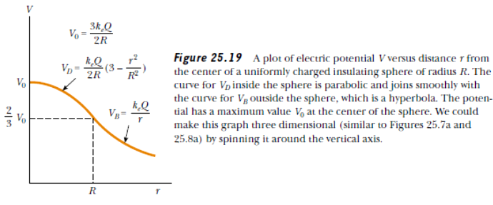**Equipotential surfaces**

An equipotential surface is a surface with a constant value of potential at all points on the surface.

For a single charge *q*, the potential is given by Eq. *V = k q/r*

1. This shows that *V* is a constant if *r* is constant . Thus, equipotential surfaces of a single point charge are concentric spherical surfaces centred

at the charge.

2. Now the electric field lines for a single charge *q* are radial lines starting from or ending at the charge, depending on whether *q* is positive or negative. Clearly, the electric field at every point is normal to the equipotential surface passing through that point. This is true in general: *for any charge configuration*, *equipotential surface through a point is normal to the electric field at that point*.





**Electrostatics of Conductors**

We shall restrict our discussion to metallic solid conductors. Let us note important results regarding electrostatics of conductors.

**1. Inside a conductor, electrostatic field is zero**

**2. At the surface of a charged conductor, electrostatic field must be normal to the surface at every point**

**3. The interior of a conductor can have no excess charge in the static situation**

**4. Electrostatic potential is constant throughout the volume of the conductor and has the same value (as inside) on its surface**

**5. Electric field at the surface of a charged conductor**

However, if the conductor is nonspherical, as in Figure 25.20, the surface charge density is high where the radius of curvature is small and the surface is convex, and it is low where the radius of curvature is small and the surface is concave. Because the electric field just outside the conductor is proportional to the surface charge density,

we see that the electric field is large near convex points having small radii of curvature and reaches very high values at sharp points.

**6. Electrostatic shielding : *the field inside the cavity is always zero*.** This is known as ***electrostatic shielding***. The effect can be made use of in protecting sensitive instruments from outside electrical influence.

Figure 2.19 gives a summary of the important electrostatic properties of a conductor.



**Problem** :A spherical balloon contains a positively charged object at its center. As the balloon is inflated to a greater volume while the charged object remains at the center, does the electric potential at the surface of the balloon increase, decrease, or remain the same? How about the magnitude of the electric field? The electric flux?

**Solution**The electric potential decreases in inverse proportion to the radius

The electric field magnitude decreases as the reciprocal of the radius squared .

Because the surface area increases as *r* 2 while the electric field magnitude decreases as 1/*r* 2, the electric flux through the surface remains constant .

**Problem :** (a) Is it possible for the magnitude of the electric field to be zero at a location where the electric potential is not zero?

(b) Can the electric potential be zero where the electric field is nonzero?

**Solution**

(a) Yes. Consider four equal charges placed at the corners of a square. The electric potential graph for this situation is shown in the figure. At the center of the square, the electric field is zero because the individual fields from the four charges cancel, but the potential is not zero. This is also the situation inside a charged conductor.

(b) Yes again for instance, the electric potential is zero at the center of the dipole, but the magnitude of the field at that point is not zero. (The two charges in a dipole are by definition of opposite sign; thus, the electric field lines created by the two charges extend from the positive to the negative charge and do not cancel anywhere.)

**Corona Discharge**

A phenomenon known as corona discharge is often observed near a conductor such as a high-voltage power line. When the electric field in the vicinity of the conductor is sufficiently strong, electrons are stripped from air molecules. This causes the molecules to be ionized, thereby increasing the air’s ability to conduct. The observed glow (or corona discharge) results from the recombination of free electrons with the ionized air molecules. If a conductor has an irregular shape, the electric field can be very high near sharp points or edges of the conductor; consequently, the ionization process and corona discharge are most likely to occur around such points.

**Dielectrics and Polarisation**

The total field in the dielectric is, thereby, reduced from the case when no dielectric is present. We should note that the surface charge density ±σ*p* arises from bound (not free charges) in the dielectric.

**___________________________________________________________________**

**Capacitors And Capacitance**

The capacitance C of a capacitor is the ratio of the magnitude of the charge on either conductor to the magnitude of the potential difference between them”

***C* = *Q/∆V***

*Why can’t we have a large potential difference in a capacitor ?*

High potential difference implies strong electric field around the conductors. A strong electric field can ionise the surrounding air and accelerate the charges so produced to the oppositely charged plates, thereby neutralising the charge on the capacitor plates, at least partly. In other words, the charge of the capacitor leaks away due to the reduction in insulating power of the intervening medium.

***Dielectric Strength***

The maximum electric field that a dielectric medium can withstand without break-down (of its insulating property) is called its *dielectric strength*; for air it is about 3 × 106 Vm–1.

For a separation between conductors of the order of 1 cm or so, this field corresponds to a potential difference of 3 × 104 V between the conductors.

*Thus, for a capacitor to store a large amount of charge without leaking, its capacitance should be high enough so that the potential difference and hence the electric field do not exceed the break-down limits.*

**Capacitance of some common capacitors**



1. **The Parallel Plate Capacitor**



**Effect of dielectric on capacitance**

The dimensionless ratio  *K =* ε / ε0  is called the *dielectric constant* of the substance.

**2.The Cylindrical Capacitor**







**3.The Spherical Capacitor**



-as the radius *b* of the outer sphere approaches infinity, the capacitance approaches the value *a*/*k*  = 4π€0*a*.

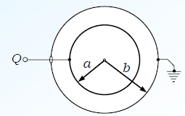1.Capacitance of two spheres when outer is earthed

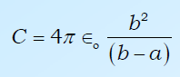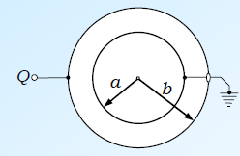

2. Capacitance of two spheres when inner is earthed

______________________________________________________________________

**The Capacitance of a spherical Conductor :**

When a charge Q is given to an isolated spherical conductor of radius R , then its potential rises.

*V =Q/4π€0R C =Q/V = 4π€0R if conductor is placed in a medium then*

*Cmed =* 4π€R or *Cmed =* 4π€€0R

**Combination Of Capacitors**

**1.Parallel Combination :** V is same but charge on each is different



**2.Series Combination :** Charge Q is same but Voltage on each is different



**Problem :** Find the equivalent capacitance between *a* and *b* for the combination of capacitors shown in Figure 26.10a. All capacitances

are in microfarads.

**Solution** Using Equations 26.8 and 26.10, we reduce the

combination step by step as indicated in the figure. The 1.0μF and 3.0μF capacitors are in parallel and combine according to the expression

***Ceq = C1 + C2 = 4***μF

The 2.0μF and 6.0μF capacitors also are in parallel and have an equivalent capacitance of 8.0 μF. Thus, the upper branch in Figure 26.10b consists of two 4.0μF capacitors in series, which combine as follows:



The lower branch in Figure 26.10b consists of two 8.0μF capacitors in series, which combine to yield an equivalent capacitance of 4.0 μF. Finally, the 2.0μF and 4.0μF capacitors in Figure 26.10c are in parallel and thus have an equivalent capacitance of 6.0 μF.

***Exercise*** Consider three capacitors having capacitances of 3.0 μF, 6.0 μF, and 12 μF. Find their equivalent capacitance when they are connected (a) in parallel and (b) in series.

***Answer*** (a) 21μF; (b) 1.7 μF.

**Energy Stored In A Charged Capacitor**



Furthermore, its capacitance *C = ∈0A/d* is (Eq. 26.3). Substituting these expressions into Equation 26.11, we obtain



Because the volume *V* (volume, not voltage!) occupied by the electric field is *Ad*,the *energy per unit volume* known as the *energy density,* is



Although Equation 26.13 was derived for a parallel-plate capacitor, the expression is generally valid. That is, **the energy density in any electric field is proportional to the square of the magnitude of the electric field at a given point.**

**Quick Quiz :** You have three capacitors and a battery. How should you combine the capacitors and the battery in one circuit so that the capacitors will store the maximum possible energy?

**Solution :** For a given voltage, the energy stored in a capacitor is proportional to *C*: . Thus, you want to maximize the equivalent capacitance. You do this by connecting the three capacitors in parallel, so that the capacitances add.

**Quick Quiz** You charge a parallel-plate capacitor, remove it from the battery, and prevent the wires connected to the plates from touching each other. When you pull the plates apart, do the following quantities increase, decrease, or stay the same? (a) *C*; (b) *Q* ; (c) *E* between the plates; (d) ∆*V* ; (e) energy stored in the capacitor.

**Solution :** (a) *C* decreases (Because C = ∈0A/d).

(b) *Q* stays the same because there is no place for the charge to flow.

(c) *E* remains constant

(d) ∆*V* increases because ∆*V* =*Q* /*C*, *Q* is constant (part b), and *C* decreases (part a).

(e) The energy stored in the capacitor is proportional to both *Q* and ∆*V* (U=1/2Q∆V) and thus increases. The additional energy comes from the work you do in pulling the two plates apart.

**Quick Quiz** Repeat the above experiment, but this time answer the questions for the situation in which the battery remains connected to the capacitor while you pull the plates apart.

**Solution :** (a) *C* decreases (Because C = ∈0A/d).

(b) *Q* decreases. The battery supplies a constant potential difference ∆*V* ; thus, charge must flow out of the capacitor if *C* = *Q* /∆*V* is to decrease.

(c) *E* decreases because the charge density on the plates decreases*.(E= σ/∈0*) (d) ∆*V* remains constant because of the presence of the battery.

(e) The energy stored in the capacitor decreases (U=1/2Q∆V).

**Quick Quiz** If you have ever tried to hang a picture, you know it can be difficult to locate a wooden stud in which to anchor your nail or screw. A carpenter’s stud-finder is basically a capacitor with its plates arranged side by side instead of facing one another.

When the device is moved over a stud, does the capacitance increase or decrease?

**Solution :** It increases. The dielectric constant of wood (and of all other insulating materials, for that matter) is greater than 1; therefore, the capacitance increases (Eq. 26.14). This increase is sensed by the stud-finder’s special circuitry, which causes an indicator on the device to light up.

**Problem** :Many computer keyboard buttons are constructed of capacitors,.When a key is pushed down, the soft insulator between the movable plate and the fixed plate is compressed. When the key is pressed, the capacitance (a) increases, (b) decreases, or (c) changes in a way that we cannot determine because the complicated electric circuit connected to the keyboard button may cause a change in ∆*V*.

**Solution**:It increases because the plate separation is decreased. Capacitance depends only on how a capacitor is constructed and not on the external circuit

**Battery Connected and disconnected approach**

**(A)Capacitor is charged and battery is disconnected ( Q is constant )**

|  |  |  |  |  |  |
| --- | --- | --- | --- | --- | --- |
| Change | Q | V=Q/C  V∝ 1/C | E =Q/∈0∈rA | C=∈0∈rA/d | U= Q2/2C  U∝ 1/C |
| Medium is filled | Unchanged | Decrease | Decrease | Increase | Decrease |
| Distance decreases | Unchanged | Decrease | Unchanged | Increase | Decrease |
| Area Increases | Unchanged | Decrease | Decrease | Increase | Decrease |

**(B)Capacitor is charged and battery is connected ( V is constant )**

|  |  |  |  |  |  |
| --- | --- | --- | --- | --- | --- |
| Change | Q =CV  Q∝ C | V=Constant | E =V/d  E∝ 1/d | C=∈0∈rA/d | U=C V2/2  U∝ C |
| Medium is filled | Increase | Unchanged | Unchanged | Increase | Increase |
| Distance decreases | Increase | Unchanged | Increase | Increase | Increase |
| Area Increases | Increase | Unchanged | Unchanged | Increase | Increase |

**Sharing of Charges:**

Consider two capacitors C1 and C2 charged to potentials V1 and V2 so that they get charges Q1 and Q2. When there corresponding plates (positive with positive) are joined in parallel, charges on both the capacitors rearrange themselves till the potential difference across both become same.

Let V be the final potential difference called common potential and let q1 and q2 be the charges on the capacitors after rearrangement.

By conservation of charges Q1 + Q2 = q1 +q2

Or C1V1 +C2V2 = C1V + C2V OR

Common potential V = (C1V1 +C2V2)/ (C1+C2)

During the process of rearrangement there is loss of energy

Loss of energy = Ui -Uf = ½ C1V12 + ½ C2V22 - ½ (C1+C2)V2 OR

Loss of energy = Ui -Uf = C1C2 (V1 –V2)2 / 2(C1+C2)

The loss in potential energy is converted into heat energy.

______________________________________________________________________

Problem : A capacitor of 20 μF is charged to 500V is connected in parallel with another of 10 μF capacity charged to 200V. What is the common potential ?

Solution : We know Common potential V = (C1V1 +C2V2)/ (C1+C2)

=[ (20 x 10-6 x 500 ) + (10 x 10-6 x 200)] / 30 x 10-6 = 400 V

*Here’s how to find out whether your calculator has a capacitor to protect values or programs during battery changes: Store a number in your calculator’s memory, remove the calculator battery for a moment, and then quickly replace it. Was the number that you stored preserved while the battery was out of the calculator?*

*_____________________________*

One device in which capacitors have an important role is the *defibrillator .* Up to 360 J is stored in the electric field of a large capacitor in a defibrillator when it is fully charged. The defibrillator can deliver all this energy to a patient in about 2 ms. (This is roughly equivalent to 3 000 times the power output of a 60-W lightbulb!) The sudden electric shock stops the fibrillation (random contractions) of the heart that often accompanies heart attacks and helps to restore the correct rhythm.

A camera’s flash unit also uses a capacitor, although the total amount of energy stored is much less than that stored in a defibrillator. After the flash unit’s capacitor is charged, tripping the camera’s shutter causes the stored energy to be sent through a special lightbulb that briefly illuminates the subject being photographed.

_________________________

A dielectric provides the following advantages:

• Increase in capacitance

• Increase in maximum operating voltage

• Possible mechanical support between the plates, which allows the plates to be close together without touching, thereby decreasing *d* and increasing *C*

**Capacitance of a capacitor with dielectric inside:**

Consider a capacitor with dielectric (k )of thickness t .Let A be the area of the plates & d be the distance between the plates.

C = ( €0A)/ (t/k + (d-t)

________________________________________________________________________

Force between the plates of a parallel plates capacitor :

In a capacitor the plates carry equal and opposite charges , therefore there is a force of attraction between the plates

F = - dU/dx where U = q2/2C

F = - q2/2€0A , Negative sign implies that the force is attractive

**Applications Of Electrostatics**

- devices as lightning rods and electrostatic precipitators and by such processes as xerography,laser printers and the painting of automobiles.

-Scientific devices based on the principles of electrostatics include electrostatic generators, the field-ion microscope, and ion-drive rocket engines.

**- Van De Graaff Generator**

**Force per unit area on a charged conductor (or electric pressure ):**

(i) If σ is the surface charge density, then electric pressure dF/dA = σ2/2∈o

(ii) The force is always directed outwards as (±σ)2 is always positive. i.e. whether body is charged positively or negatively, this force always try to expand the charged body.

(iii) A soap bubble or rubber balloon expands on giving a positive or negative charge to it.

**Recap Capacitance**

- Electric potential energy stored in a charged capacitor: U=½CV2

- The energy is stored in the electric field between the plates of a charged capacitor.

-The energy stored per unit volume in the electric field between the plates is called energy density

u=½∈oE2 = σ2/2∈o where σ represents surface charge density on the plates of capacitor.

-Force of attraction between oppositely charged plates of a capacitor is given as:

F=Q2/2∈o A =½∈oE2 A therefore pressure P =F/A =½∈oE2 = σ2/2∈o

- For an air filled spherical capacitor: C= 4 π∈o ab/(b-a)

- For an air filled cylindrical capacitor: C= 2 π∈o L/loge(b/a)

-For two long parallel wires: C= ∈o L/loge(d/a) (where L is the length, d is the separation between the wires and a is the radius of each wire with d >> a).

-If the upper plate of the parallel plate condenser is connected to the lower plate, then its electrical capacitance becomes infinity.

-If a sheet of aluminium foil of negligible thickness is placed exactly at the centre of the two plates of a parallel plate condenser and the foil is connected to the upper plate, then the capacitance is doubled since

d is reduced to half

-If a dielectric slab of thickness t and dielectric constant K is introduced between the plates, then the capacity of the condenser is given by:

-If the dielectric slab is replaced by a metallic slab of same thickness, then

-It is interesting to note here that Cmetal> Cdielectric

-If a metal slab of thickness d/2 is inserted in between the plates, then the capacitance becomes:

-A parallel plate condenser is used to produced uniform electric field between the plates.

Regrouping of condensers

(a) Two condensers of capacity C1 and C2 are charged separately to potentials V1 and V2. If the condensers are now connected with plates of same polarity together, then according to law of conservation of charge,

C1V1 +C2V2 =(C1 + C2)V therefore V =common potential = (C1V1 +C2V2 )/ (C1 + C2)

(b) Initial Energy stored Ui = ½ C1(V1)2 + ½ C2(V2)2

Final Energy stored Uf = ½ (C1 + C2)V2



Loss of energy = ∆U = Ui - Uf = ½ (C1 + C2)V2)2

Final charges in two condensers q1 = C1V & q2 =C2V

-If a condenser of capacity C1 is charged to a potential V and then connected to an uncharged condenser of capacity C2 in parallel, then the common potential is:



-Two condensers of capacities C1 and C2 are charged separately to potentials V1 and V2. If they are reconnected in parallel with plates of opposite polarity together, then the common potential is given by:

-Three capacitors of capacities C1 ,C2 and C3 are connected in series with a battery. If the capacitors are disconnected from the line and reconnected in parallel with positively charged plates together, then the common potential is given by

C1V1 + C2V2 + C3V3 =(C1 + C2 + C3)V As Q = C1V1 = C2V2 = C3V3 = CsV

Hence V =common potential = (C1V1 +C2V2 +C3V3)/ (C1 + C2 + C3 ) = 3Q/(C1 +C2 +C3)

-If n drops each of radius r and charge q are joined to form a bigger drop, then for bigger drop:

(a) total charge = nq (b) total capacity = n1/3C

(c) total potential = n2/3V (d) total stored energy = n5/3 U

(e) surface charge density =n1/3σ

**Series grouping of capacitors :**

(i) If a number of capacitors are connected end to end, so that all the capacitors will get the same charge Q, then they are said to be connected in series, i.e., Q1:Q2:Q3 =1 : l : l

(ii) In series grouping, if V1,V2,V3 are the potential differences across the capacitors, then applied potential difference

V =V1 + V2 + V3

Hence Q/Cs = Q/C1 +Q/C2 +Q/C3 or1/Cs = 1/C1 + 1/C2 + 1/C3

Here, effective capacitance Cs, is even less than the least of the individual capacitances.



- If n identical capacitors, each of capacity C, are joined in series, then the effective capacitance is

given by: Cs =(C/n).

**Parallel grouping of capacitors:**

(i) If a number of capacitors are connected between the same two terminals, so that the potential difference

across every one of them is same, then they are said to be connected in parallel, i.e. V1 : V2 : V3 =1 : l : l

(ii) Here Q = Q1 + Q2 + Q3  OR CpV = C1V+C2V +C3Vor Cp = C1 +C2  +C3

Here, the effective capacitance Cp is equal to the sum of their individual capacities.

Q1:Q2:Q3 = C1 : C2 : C3

- If n capacitors of capacity C are connected in parallel, then the equivalent capacity is given by

CP=nC

- If Cp is the effective capacity when n identical capacitors are connected in parallel and Cs is their effective capacity when connected in series, then Cp/Cs =*n*2

**Effect of dielectric:**

(i) Effect of inserting dielectric slab: On capacitance, , potential difference, charge, intensity of the electric field and energy stored with battery still in connection

(a)C = KCo (b)V = Vo (c) Q= K Qo (d) E= Eo (e)U = ½CV2 = ½KCoVo2 = K Uo

(ii) Battery is disconnected and dielectric slab inserted :

a)C = KCo (b)V = Vo/K (c) Q= Qo (d) E= Eo/K (e)U = ½CV2 = ½KCo(Vo/K)2 = Uo/K

(iii) Capacitor is charged and then battery is disconnected: If the distance between the two plates is increased by insulating handles, then:

(a) capacity decreases, (b) potential difference increases,

(c) intensity of electric field remains same, (d) charge on the plates remains same and

(e) energy stored in the capacitor increases.

***Problem solving hints for Capacitors (IIT – Advanced/Main)***

*- V.Imp :* Remember that electric potential is a scalar quantity, so components need not be considered. Therefore, when using the superposition principle to evaluate the electric potential at a point due to a system of point charges, simply take the algebraic sum of the potentials due to the various charges.

However, you must keep track of signs. The potential is positive for positive

charges, and it is negative for negative charges.

*-* Just as with gravitational potential energy in mechanics, only *changes* in electric potential are significant; hence, the point where you choose the potential to be zero is arbitrary.

When dealing with point charges or a charge distribution of finite size, we usually define *V* = 0 to be at a point infinitely far from the charges.

- Once you know the electric potential at a point, you can obtain the electric

field at that point by remembering that the electric field component in a specified direction is equal to the negative of the derivative of the electric potential in that direction.

-Be careful with units. When you calculate capacitance in farads, make sure

that distances are expressed in meters and that you use the SI value of ∈0 .

When checking consistency of units, remember that the unit for electric fields can be either N/C or V/m.

-When two or more capacitors are connected in parallel, the potential difference across each is the same. The charge on each capacitor is proportional to its capacitance; hence, the capacitances can be added directly to give the equivalent capacitance of the parallel combination. The equivalent capacitance is always larger than the individual capacitances.

-When two or more capacitors are connected in series, they carry the same charge, and the sum of the potential differences equals the total potential difference applied to the combination. The sum of the reciprocals of the capacitances equals the reciprocal of the equivalent capacitance, which is always less than the capacitance of the smallest individual capacitor.

-A dielectric increases the capacitance of a capacitor by a factor *k* (the dielectric constant) over its capacitance when air is between the plates.

-For problems in which a battery is being connected or disconnected, note whether modifications to the capacitor are made while it is connected to the battery or after it has been disconnected. If the capacitor remains connected to the battery, the voltage across the capacitor remains unchanged (equal to the battery voltage), and the charge is proportional to the capacitance, although it may be modified (for instance, by the insertion of a dielectric).

If you disconnect the capacitor from the battery before making any modifications to the capacitor, then its charge remains fixed. In this case, as you vary the capacitance, the voltage across the plates changes according to the expression ∆*V* =*Q* /*C*.

**Points To Ponder**

1. Electrostatics deals with forces between charges at rest. But if there is a force on a charge, how can it be at rest? Thus, when we are talking of electrostatic force between charges, it should be understood that each charge is being kept at rest by some unspecified force that opposes the net Coulomb force on the charge.

2. A capacitor is so configured that it confines the electric field lines within a small region of space. Thus, even though field may have considerable strength, the potential difference between the two conductors of a capacitor is small.

3. Electric field is discontinuous across the surface of a spherical charged shell. It is zero inside and σ /ε0outside. Electric potential is, however continuous across the surface, equal to *q*/4πε0*R* at the surface.

4. The torque **p × E** on a dipole causes it to oscillate about **E**. Only if there is a dissipative mechanism, the oscillations are damped and the dipole eventually aligns with **E**.

5. Potential due to a charge *q* at its own location is not defined – it is infinite.

6. In the expression *qV* (**r**) for potential energy of a charge *q*, *V* (**r**) is the potential due to external charges and not the potential due to *q*. As seen in point 5, this expression will be ill-defined if *V* (**r**) includes potential due to a charge *q* itself.

7. A cavity inside a conductor is shielded from outside electrical influences.It is worth noting that electrostatic shielding does not work the other way round; that is, if you put charges inside the cavity, the exterior of the conductor is not shielded from the fields by the inside charges.

**Unit Conversion esu for Competition Questions**

|  |  |
| --- | --- |
| Electric current, I esu | 3.3 ×10-10 A |
| Electric charge, Q I esu | 3.3 ×10-10 C |
| Electrical potential, V, I esu = 1 esv | 300 V |
| Electric field, E I esu | 3 ×104  V/m |
| Electric dipole moment, p, I esu | 3.3 ×10-12 Cm |

**Problems Capacitance**

-Amount of charge required to be given to the object to increase it’s potential by one volt is called capacitance of the object.

-Earthing a device means forcing it’s potential to zero.

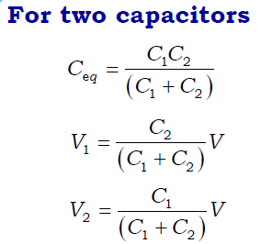

- Capacitors in series 1/Ceq = Σ 1/C

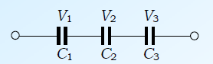

- **Capacitors in Parallel** Ceq = ΣC

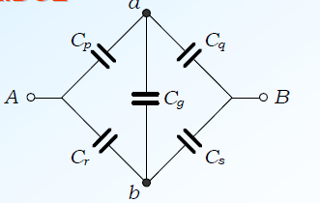- Capacitors in Wheatstone Bridge : five similar elements connected according to shown configuration is called Wheatstone Bridge

- no two elements in wheatstone bridge are in series or parallel.

-For bridge to be balanced Va =Vb because Cp/Cq =Cr/Cs

Ceq = (Cp + Cr ) (Cq +Cs ) / (Cp +Cr +Cq +Cs )

**Symmetry considerations :**

-If a capacitive network is symmetrical about line joining terminals ,all points in one half of the network are equipotential with the corresponding points in the other half of the network.

--If a capacitive network is symmetrical about line perpendicular to the line joining terminals,all points lying on the line of symmetry are equipotential.

--If two capacitors are connected in series or in parallel, then we have ways of dealing with them. It is not true that any two capacitors must be either in series or parallel, but if they are then we can do something with them.

*When two devices are connected so that all of the charge that leaves one must go through the other, we say they are in series. Likewise when two devices are connected so that they must have the same voltage, we say they are in parallel.*

**How do we determine whether two capacitors are in series?**

-Consider C1 and C2 above. Charge passes from A through C1 to B. From there the charges can only go to C and through C2 to D. C1 and C2 are in series because the charges that pass through C1 must then go through C2, and the charges that pass through the two must be equal.

-Charges that pass through C2 to point D can go either through C3 to F or through C4

to H. The charges through C2 and C3 do not have to be equal, so C2 and C3 are not in series.

**How do we determine whether two capacitors are in parallel?**

-Consider C3 and C4 above. Take a finger from each hand, and place them at each end of C3. The voltage difference between your fingers is equal to the voltage difference between the ends of C3, or the voltage across C3. Now try moving your fingers, but only along wires and not across any circuit element, such as a capacitor or battery. If by doing this you can get your fingers to lie at the two ends of C4, then C3 and C4 have the same voltage across them and they are in parallel (they are, and you should be able to do this).

-Are C3and C2 in parallel?

We can move a finger from E to D but we can't get from F to C. We could only do this by jumping from one wire to another nearby wire (not allowed), or by going through the battery and C1 (also not allowed). Therefore, C3 and C2 are not in parallel. Even though both are drawn vertically, so that they are geometrically parallel, they are not electrically parallel.

**Any two capacitors do not have to be either in series or in parallel.**

If two capacitors are in series, then they can be treated as if they were a single capacitor. The capacitance of this replacement or "equivalent" capacitor is

Cs = C1C2/(C1+C2)

If two capacitors are in parallel, then they can be treated as if they were a single capacitor. The capacitance of this replacement or "equivalent" capacitor is

Cp= C1 + C2

____________________________________________

**Problems : find equivalent capacitance of the following circuits:**

1. Find equivalent capacitance of the following circuit:



2. Find equivalent capacitance of the following circuit:



3. Find equivalent capacitance of the given circuit:



4. . Find equivalent capacitance of the given circuit:



5. Find equivalent capacitance of the given circuit:

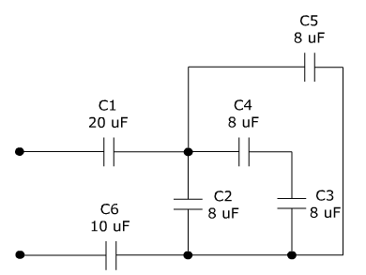

6. Find equivalent capacitance of the given circuit:

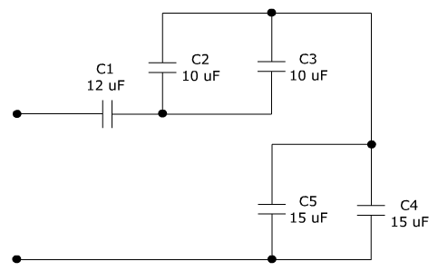

7. Find equivalent capacitance of the given circuit:

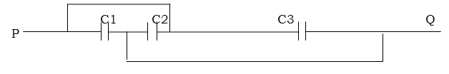8. Find equivalent capacitance of the given circuit:

9. Find equivalent capacitance of the given circuit:

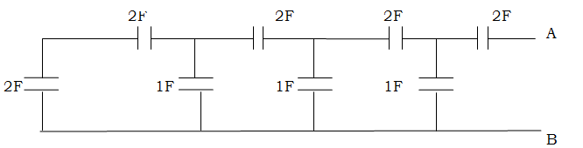

10. Four capacitors are as shown with C1 =3F ,C2=C3=C4 =9F.Find equivalent capacitance.

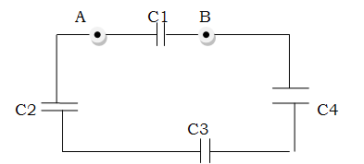

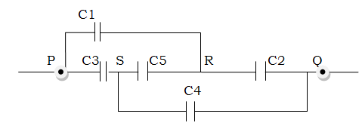

11. Find equivalent capacitance of the given circuit:

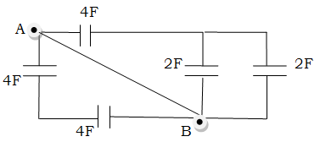

12. Find equivalent capacitance of the given circuit:

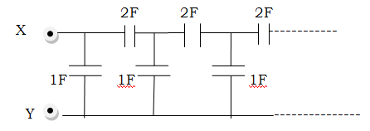

13. Find equivalent capacitance of the given circuit:

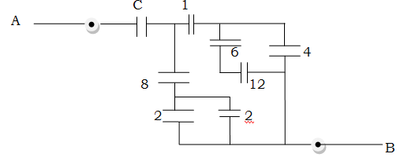

14. Find equivalent capacitance between A & B:

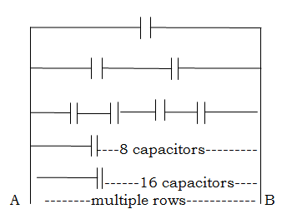

15. Find equivalent capacitance of the given circuit:

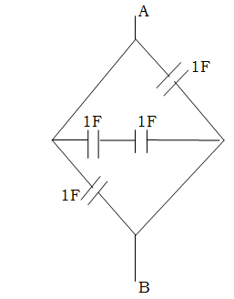

16. Find equivalent capacitance of the given circuit:

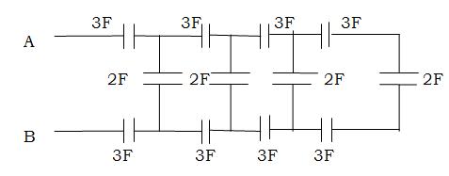

17. Find equivalent capacitance of the given circuit:

18. Six equal capacitors of capacitance C are connected as shown in the fig.Find equivalent capacitance.

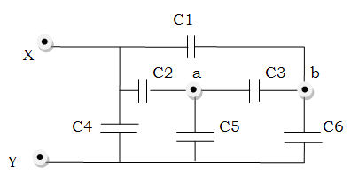

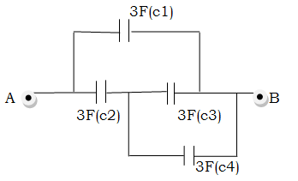

19. Find equivalent capacitance of the given circuit:

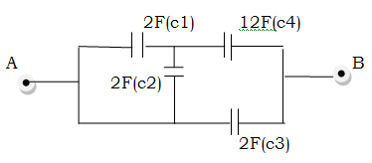

20. Find equivalent capacitance of the given circuit:

**Problems involving plates of capacitors:**

On a system of **n** parallel plates

- Half of the net charge appears on each of the outermost surfaces of outermost plates.

-Facing surfaces always bear same amount of charge with opposite sign.

-Net charge on any of the isolated plates remains conserved.

-Potential difference between two consecutive plates is given by V =*qd*/∈oA = q/c , where q is the charge on the facing plate.

**Capacitance for n plates arranged in parallel as shown**

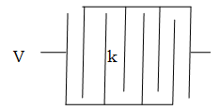where k is the dielectric constant and d is the distance between two consecutive plates.

Cp = (n-1)∈o Ak/d

**Capacitance for n plates arranged in series as shown**

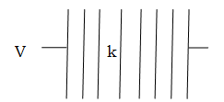

Cs = ∈o Ak/d(n-1)

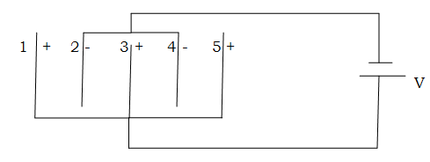

**Problems**

1. 5 identical capacitor plates are connected as shown find the equivalent capacitance and charge on plate 1 & 4.

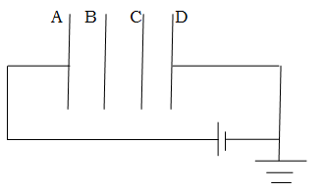

2. Find capacitance of the combination. Also write potentials on A,B ,C and D.

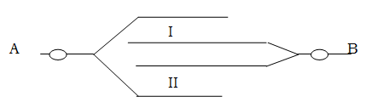

3. What is the capacitance of the combination?

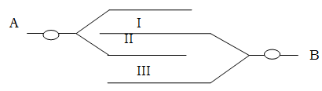

4. What is the capacitance of the combination?

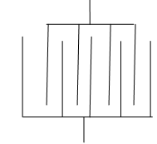

5. Find Ceq , if d= 0.885 cm and A =5cm2

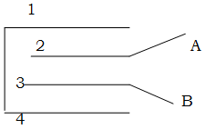

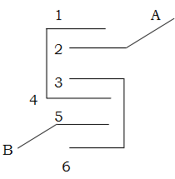6.Find capacitance of the plate network as shown ?

7.Find capacitance of the plate network as shown ?

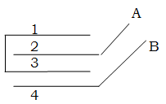

8.Find capacitance of the plate network as shown ?

**Problems with different combinations of dielectrics**

-. If space between plates is fully filled with dielectric (k) then Ck = *k* C

-If slabs parallel to plates are introduced between plates of a parallel plate capacitor then

in this case distance d is divided but area A remains same. different capacitors are in series with each other Individual capacitance is C1 = ∈oAk1/t1

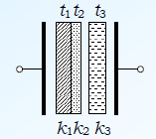

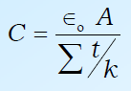

-If slabs perpendicular to plates are introduced between plates of a parallel plate capacitor then

-Area (A) is divided but distance ‘d’ remains same

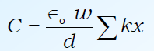-capacitors are in parallel

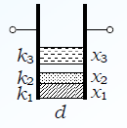

C= ∈o/d {k1A1+k2A2+....}

where *w* is the width of the plates ( A = *w* x Σ*x* )

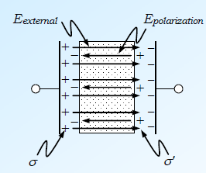-Induced charge on the surface of the dielectric..

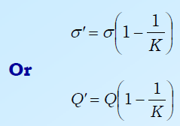

**Problems**

1. A parallel plate capacitor is filled with two dielectrics as shown .What is the equivalent capacity ?

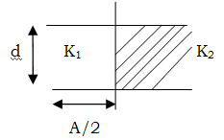

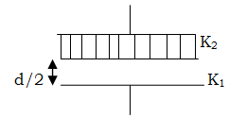

2. A parallel plate capacitor is filled with two dielectrics as shown .What is the equivalent capacity?

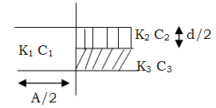

3.Calculate the capacitance of the capacitor as shown in fig.

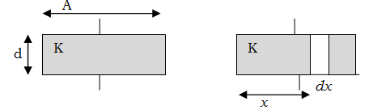4.Figure shows a parallel plate capacitor having square plates of edge ‘A’ and plate separation ‘d’ .The gap between the plates is filled with a dielectric of dielectric constant K which varies parallel to and edge as *K = Ko + αx* ,where *Ko* and *α* are constants and *x* is the distance from the left end.Calculate the capacitance.

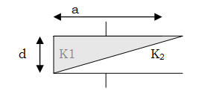

5 A capacitor is formed by two square plates of edges ‘a’ ,separated by distance ‘d’ .Dielectrics of dielectric strength K1 & K2 are filled in the gap as shown. Find the capacitance of the arrangement.

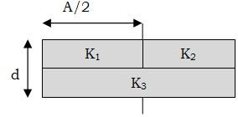

6.If a single dielectric is to be used instead of these three dielectrics find it’s value ?

**Answers :**



1. Answer :

-The voltage across the 5 μF capacitor is 6 volts because you can do finger test to confirm that.

- Is the 6 μF capacitor in parallel with the battery? (If the 6 pF capacitor is in parallel with the battery, then it has the same potential across it as the battery does. I put one finger on each side of the 6 μF capacitor and try to move them to the two sides of the battery. The top one slides over to the top of the battery. The bottom one has to jump over the 2 μF capacitor or the 4 μF capacitor. . .)

-So the 6 μF capacitor is not in parallel with the battery.

-Neither the 2 μF capacitor nor the 4 μF capacitor is in parallel with the battery either.

**Are the 6 μF capacitor and the 4 μF capacitor in series or parallel?**

Does all of the charge that comes out of the bottom of the 6 μF capacitor have to go into the 4 μF capacitor, or could some of it go somewhere else?

--Some of the charge could go into the 2 μF capacitor. To be in series, all of the charge from one must go into the other. So the 6 μF capacitor and the 4 μF capacitor aren't in series.

Okay. let’s check to see if the 4**μF** is in parallel with the 6**μF**. I we put one finger on each side of the 4 **μF** capacitor, and try to move them to the two sides of the 6 **μF** capacitor. I can move one from the top of the 4 to the bottom of the 6, but I can't move the other from the bottom of the 4 to the top of the 6.

“ **Remember** **Any two capacitors do not have to be either in series or in parallel.”**

**And the 6 μF capacitor isn't in series with the 2 μF capacitor either**

**Nor is the 4 μF capacitor in series with the 2 μF capacitor**

-But 4μF and 2μF are in parallel and will become a single capacitor of 6 μF , which in turn is in series with the other 6μF capacitor.

Cs = C1C2/(C1+C2) = 3μF

Now 3μF capacitor is in parallel with 5μF capacitor giving a total capacitance of 8μF

**Answer 2.**



All the three capacitors in above figure are connected in parallel combination

Thus, C”=C/2 +C/2 + C = 2C This is the required equivalent capacitance

_______________________________________________________________

**3**.Now using the finger test we can confirm that 2 and 3 are in parallel giving 5μF capacitor.

Therefore we have 3 capacitors in series therefore

1/Cs = 1/12 +1/5 + 1/20 = (5+12+3)/60 = 20/60 = 1/3

Cs = 3μF

______________________________________________________________



4. Using Wheat stone bridge result we get

Ceq = (Cp + Cr ) (Cq +Cs ) / (Cp +Cr +Cq +Cs )

= ( 10+10) (10+10) / (10+10+10+10) = 400/40 = 10

__________________________________________________________



5.

Now 8 and 10 are in parallel. Therefore we have two capacitors of 18 and 10 μF in series.

Cs = 18 x 10/ 28 = 180/28 = 6.4μF



6.Now C4 and C3 are in series therefore C34= 4

Now C34 , C2 and C5 are all in parallel therefore Cp= 8+8+4 =20

We have now three capacitors of 20,20 and 10 in series which will give Ceq = 5μF



7.Now C2 and C3 are in parallel resulting in 20μF

- C5 and C4 are also parallel resulting in 30μF

- We are left with 3 capacitors of 12 ,20 and 30 μF all in series which will give resultant capacitance of 6μF.



8.

Note that each plate of three capacitors ( left of C1 ,right of C2 and left of C3) is connected to P whereas each other plate is connected to Q. Therefore all 3 are in parallel giving

Ceq = C1+C2+C3.



9.

Starting from the left side of the network the two 2F capacitors are in series giving resultant capacitance of 1F.

Now this equivalent capacitor of 1F is in parallel with 1F capacitor giving 2F resultant capacitor.

Proceeding in this way we will finally get two capacitors of 2F in series giving final capacitance of 1F.

**10.** Four capacitors are as shown with C1 =3F ,C2=C3=C4 =9F.Find equivalent capacitance.

Now C2,C3 and C4 are connected in series giving Cs = 3F.

With Cs and C1 in parallel equivalent capacitance is 6F

11. The given configuration can be rearranged into a wheatstone bridge

as c1=c2=c3=c4 = 4F and C5 = 5F

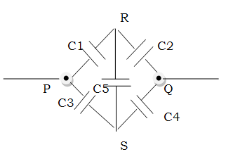also as C1/C2 = C3/C4 , therefore the bridge is balanced.

As the point R and S are at same potential therefore no charge can accumulate at C5.

Applying the wheatstone formula Ceq = (Cp + Cr ) (Cq +Cs ) / (Cp +Cr +Cq +Cs )

or Noting that two series combinations (C1,C2) and (C3,C4) are parallel to each other.

Therefore Cs = 2F and Cp= Cs+Cs = 4F.

**12**.

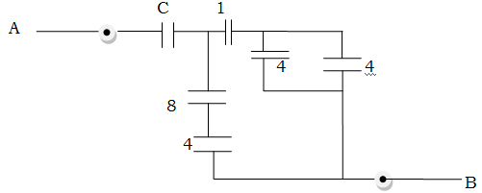



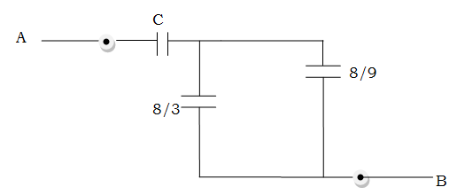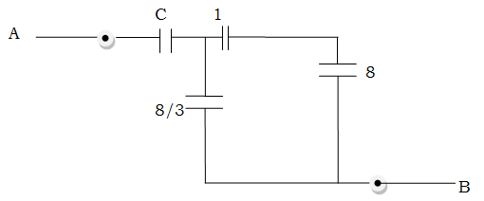

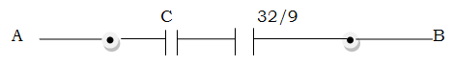

**Cs = 1/C +9/32**

13. Let C be the capacitance of the infinite ladder.As the ladder is infinite therefore addition of one more element of 1F and 2F will not alter the result.

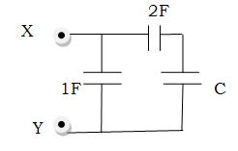

Now Cs = 2C/(C+2)

Final capacitance Cp = C = 1+2C/(C+2)

or C2-C-2 =0 , which gives C =2F (Neglecting negative value)

14.Find equivalent capacitance between A & B.

- Now 2 & 2 are in parallel giving 4F capacitance

- This 4F is in series with 4F capacitor giving Cs=2F

-Similarly 4F & 4F are in series resulting in 2F Capacitance.

- Now we are left with two capacitors of 2F and 2 F in parallel giving Cp= 2+2 = 4F

_____________________________________________________________

15.In each row the capacitors are in series and different rows are joined in parallel. Therefore total capacity

C = C +C/2 +C/4 +C/8 +C/16 +---------∞

or

C =C (1 + ½ + ¼ + 1/8 +-----∞ ) = C (1)/(1-1/2 ) = 2C =2F





16.Now the given configurations means three capacitors of 1F ,0.5F and 1F in parallel to each other .Therefore

C = 1+0.5+1 = 2.5F



17.starting from the right side the three capacitors of 3,2 & 3F are in series giving resultant of Cs= 6/7 F.

This Cs is in parallel to the 2 F capacitor giving Cp = 2+6/7 = 20/7

This 20/7 F capacitor is in series with the two 3F capacitors...solving for the circuit like this the resultant would be three 3F capacitors in seris which will give final capacitance as 1 F.



**18**.Six equal capacitors of capacitance C are connected as shown in the fig.Find equivalent capacitance.

The given network can be redrawn as follows.

C4 is in parallel with balanced wheat stone bridge having equivalent capacitance given by

Ceq = (Cp + Cr ) (Cq +Cs ) / (Cp +Cr +Cq +Cs )

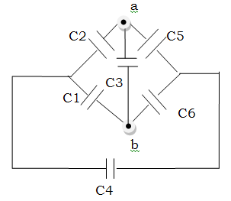therefore Ceq = C. Now this Ceq is in parallel with C4 therefore net capacitance would be C+C = 2C



19.Now c3 and c4 are in parallel giving a capacitor of 6F which is in series with c2.Therefore c2 and 6F will result in 2F capacitor which is in parallel with c1.

The Ceq = 3””+2 F = 5F



20.C1 and C2 are in parallel giving 4F.Resultant is in series with C4 and their combination is in parallel to C3.Answer is 5F.

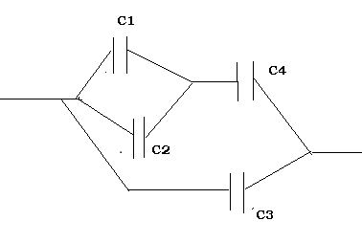

**Answers - Problems involving plates of capacitors:**

1. The five plates make up 4 capacitors each of capacity ∈o A/d all connected in parallel.

Therefore equivalent capacitance is

C = (n-1)∈o Ak/d , where n is the number of plates

C = (5-1) ∈o A/d = 4∈o A/d (because n=5 and k=1)

Now as plate 1 is connected to +ve side of battery and is a part of only one capacitor ,therefore charge on it is

q1 = + c1.V = + ∈o AV/d

However plate 4 is connected to –ve of battery terminals and is part of two capacitors therefore

q4 = - 2q1 = - 2. ∈o AV/d = - 2∈o AV/d

_________________________________________________

2. Since this is case of series combination we will use expression Cs = ∈o Ak/d(n-1)

or C = ∈o A/d(4-1)= ∈o A/3d

-Now since plate D is earthed therefore VD =0 .

-Plate A is connected directly to battery therefore VA =V ; VB and VC are respectively 2V/3 and V/3.

3. If we connect A to negative of battery terminal and B to the positive of battery terminals.Then we will get two capacitors in the region I and II having capacitance each =∈o A/d



Since positive plate of I is connected with the positive plate of II therefore they are in parallel.

Hence Ceq = C+C = 2∈o A/d

4. we will have 3 capacitors or four plates joined in parallel.Using the expression for parallel combination

Cp = (n-1)∈o Ak/d Cp = (4-1)∈o A/d or Cp = 3∈o A/d





5.Now this is parallel combination with n=9 . Using the expression for parallel combination

Cp = (n-1)∈o Ak/d Cp = (9-1)∈o A/d or Cp = 8∈o A/d

Cp = 8∈o A/d = (8 x 8.54 x 10-12 x 5 x 10-4)/885 x 10-5

= (8 x 8.54 x 5 x 10-11)/885

= 0.4 x10-11 = 4pF

**6** The plate network can be rearranged as shown in the next diagram.

where two capacitors are in series giving equivalent capacitance of C/2.

This C/2 combination is in parallel with C therefore

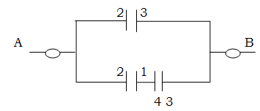Ceq = C +C/2 = 3/2 C

**7**. Rearranged plates show balanced wheatstone bridge hence capacity =C

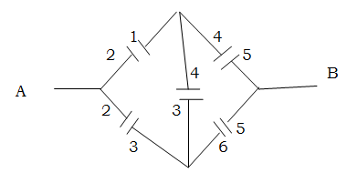



**8.** Rearranged plates show three capacitors as shown. with the Cp = 2C and then

Ceq = 2 C /3

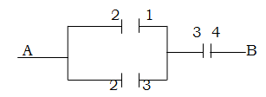

**Answers : Problems with different combinations of dielectrics**



1.Answer :

C= ∈o/d {k1A1+k2A2+....} or C = C= ∈o/d (k1A/2+ k2A/2 )

C = ∈o A(k1+k2 ) /2d

2.

therefore C = ∈o A/(d/2K1+d/2K2) = 2∈o A K1 K2/d(K1 + K2)

3.Calculate the capacitance of the capacitor as shown in fig.

Answer :

C1= (∈o K1A/2) /d = ∈o K1A/2d

C2= (∈o K2A/2) /(d/2) = ∈o K2A/d

C3= (∈o K3A/2) /(d/2) = ∈o K3A/d

Now C2 and C3 are in series therefore 1/Cs = 1/C2 +1/C3 = d /∈o K2A + d /∈o K3A

1/Cs = = d /∈o A (1/K2 + 1/K3) Cs = ∈o A (K2K3) / d (K2 +K3)

Cs again is in parallel with C1 . Therefore

Ceq = Cs+C1 = ∈o A (K2K3) / d (K2 +K3) +∈o K1A/2d = (∈o A/d ) [ (K2K3)/(K2 +K3) +K1/2 ]

**4**.Consider a small strip of length *dx* at a distance *x* from the left end.The strip forms a small capacitor of plate area *Adx* .

It’s capacitance is

dC = (*Ko + αx )*∈o *Adx* /d

The given capacitor can be divided into such strips with *x* varying from 0 to A. All these strips are connected in parallel.

The capacitance of the given capacitor is

C = A∫o (*Ko + αx )*∈o *Adx* /d = [(∈o A2)/d ] [*Ko + Aα/2* ]

5..



Consider an elemental capacitor of width ‘dx’ at a distance ‘x’ from one end. It is constituted of two capacitor elements of dielectric constants k1 and k2 with plate separation xtanϕ and d –xtanϕ respectively in series



6..If a single dielectric is to be used instead of these three dielectrics find it’s value ?



Answer :

C1 = (∈o K1A/2) /(d/2) = ∈o K1A/d

C2 = (∈o K2A/2) /(d/2) = ∈o K2A/d

C3 = (∈o K3A) /(d/2) = 2 ∈o K3A/d

Now C1 C2 are in parallel therefore Cp = C1 + C2 =∈o K1A/d +∈o K2A/d

or = ∈o A(K1+ K2)/d

Now Cp and C3 are in series giving 1/Ceq = 1/Cp  + 1/C3 = d /∈o A(K1+ K2) + d/2 ∈o K3A

1/Ceq = (d /∈o A) [1/ (K1+ K2) + 1/2 K3] = (d /∈o A) [(K1+ K2 +2 K3) / (2 K3(K1+ K2) )]

Ceq = {∈o A/ d} [(2 K3(K1+ K2) /(K1+ K2 +2 K3)]

The equivalent dielectric constant K = [(2 K3(K1+ K2) /(K1+ K2 +2 K3)]

or 1/K = 1/(K1 +K2 ) + 1/2K3

**Home Assignment- Electric Charges & Field**

1. Define *Electrostatics,* Point Charges and the Principle of Superposition
2. State Coulomb’s Law and write expression in normal form ,vector form and in medium other than vacuum ?
3. If a charge *Q* is to be divided into two parts such that the force between them is to be maximum, then how would you divide them ?
4. Two identical conductors having charges *q*1 and *q*2 are put in contact and then separated, find the final charges on both of them with different cases ?
5. Two charges *Q* each are at a distance *r* from each other. At what distance a third charge (Q/4) should be placed so that all the charges are in equilibrium ? (write answer after due calculation )
6. You want to check whether the two conductors are charged or uncharged , what would be the sure test for that ?
7. Consider three charges *q*, *q,* and –*q* placed at the vertices of an equilateral triangle. What is the force on each charge?
8. Define electric field?



1. An electron falls through a distance of 1.5 cm in a uniform electric field of magnitude 2.0 × 104 N/C [Fig. 1.13(a)]. The direction of the field is reversed keeping its magnitude unchanged and a proton falls through the same distance [Fig. 1.13(b)]. Compute the time of fall in each case. Contrast the situation with that of ‘free fall under gravity’.
2. Define electric field lines and at least 5 properties?
3. Draw electric field lines due to a combination of +2q & -q charge placed some distance apart?
4. Derive an expression for Electric field due to a Charged Rod ?
5. Derive an expression for Electric field due to a uniform ring of charge ?
6. Derive an expression for Electric field due to a uniformly charge disk ?
7. Define an electric dipole ?Also explain terms direction of dipole and center of dipole ?
8. Derive an expression for Electric field due to an electric dipole for the following cases?

(a) when the point is on the dipole axis, and

(b) when it is in the *equatorial plane* of the dipole, i.e., on a plane perpendicular to the dipole axis through its centre.

1. Derive an expression for torque in a uniform external field?
2. Define electric flux and write it’s S.I. unit ?When the flux would be maximum and minimum thru an area ?
3. Define Gauss’s law for electrostatics ?
4. Using Gauss’s law derive the expressions for the following :

(a)The Electric Field due to a Point Charge

(b)The Electric Field due to a Spherically Symmetric Charge Distribution

(c)The Electric Field due to a thin spherical shell

(d) (The Electric Field due to a uniformly charged infinite plane sheet.

1. The electric field components in Fig. 1.27 are *Ex* = α*x*1/2, *Ey* = *Ez* = 0, in which α = 800 N/C m1/2.

Calculate (a) the flux through the cube, and

(b) the charge within the cube. Assume that *a* = 0.1 m.

1. An electric field is uniform, and in the positive *x* direction for positive *x*, and uniform with the same magnitude but in the negative *x* direction for negative *x*. It is given that **E** = 200 ˆ**i** N/C for *x* > 0 and **E** = –200 ˆ**i** N/C for *x* < 0.
2. What is the force between two small charged spheres having charges of 2 × 10–7 C and 3 × 10–7 C placed 30 cm apart in air?
3. Check that the ratio *ke*2/*G memp* is dimensionless.
4. Four point charges *q*A = 2 μC, *q*B = –5 μC, *q*C = 2 μC, and *q*D = –5 μC are located at the corners of a square ABCD of side 10 cm. What is the force on a charge of 1 μC placed at the centre of the square?
5. An electric dipole with dipole moment 4 × 10–9 C m is aligned at 30° with the direction of a uniform electric field of magnitude 5 × 104 N/C. Calculate the magnitude of the torque acting on the dipole.
6. A polythene piece rubbed with wool is found to have a negative charge of 3 × 10–7 C.
   1. Estimate the number of electrons transferred (from which to which?)
   2. Is there a transfer of mass from wool to polythene?
7. A conducting sphere of radius 10 cm has an unknown charge. If the electric field 20 cm from the centre of the sphere is 1.5 × 103 N/C and points radially inward, what is the net charge on the sphere?
8. An infinite line charge produces a field of 9 × 104 N/C at a distance of 2 cm. Calculate the linear charge density.
9. An arbitrary surface encloses a dipole. What is the electric flux through this surface?
10. A metallic spherical shell has an inner radius *R*1 and outer radius *R*2. A charge *Q* is placed at the centre of the spherical cavity. What will be surface charge density on (i) the inner surface, and (ii) the outer surface?
11. If the total charge enclosed by a surface is zero, does it imply that the electric field everywhere on the surface is zero? Conversely, if the electric field everywhere on a surface is zero, does it imply that net charge inside is zero.
12. Sketch the electric field lines for a uniformly charged hollow cylinder shown in Fig 1.8.
13. What will be the total flux through the faces of the cube (Fig. 1.9) with side of length *a* if a charge *q* is placed at
    1. A: a corner of the cube.
    2. B: mid-point of an edge of the cube.
    3. C: centre of a face of the cube.
    4. D: mid-point of B and C.
14. Two charges *q* and –3*q* are placed fixed on *x*-axis separated by distance ‘*d*’. Where should a third charge 2*q* be placed such that it will not experience any force?



1. Fig. 1.11 shows the electric field lines around three point charges A, B and C.
   1. Which charges are positive?
   2. Which charge has the largest magnitude? Why?
   3. In which region or regions of the picture could the electric field be zero? Justify your answer. (i) near A, (ii) near B, (iii) near C, (iv) nowhere
2. Write the following conversions Unit Conversion esu for Competition Questions

|  |  |
| --- | --- |
| Electric current, I esu | ........ A |
| Electric charge, Q I esu | ......... C |
| Electrical potential, V, I esu = 1 esv | ........... V |
| Electric field, E I esu | ............ V/m |
| Electric dipole moment, p, I esu | ..........Cm |

1. plot a graph showing the variation of Coulomb force F versus (1/r2) , where r is the distance between two charges of each pair of charge (1μc,2μc) and (2μc . -3μc).Interpret the graphs obtained ?
2. What is the relevance of large value of k =81 for water ?
3. In coulomb’s law ,on what factors does the value of electrostatic force constant K depends ?
4. Force of attraction between two point charges placed ata distance ‘d’ if F. What distance apart should they be placed in the same medium so that the force between them is F/3 ?
5. Dielectric constant of a medium is unity. What will be it’s permittivity ?
6. Explain what is meant by dielectric constant? Give some examples ?
7. In which orientation a dipole when placed in a uniform field has (a) stable (b) unstable equilibrium ?
8. Two charges of -4μC & +4μC are placed at the points A(1,0,4) and B (2,-1,5) located in an electric field **E** = 0.20i V/cm. Calculate the torque acting on the dipole ?

**Home Assignment- Electric Potential and Capacitance**

1. Define electric potential difference along with units ?
2. “Electric field lines always point in the direction of decreasing electric potential” ,Justify this statement with suitable expression ?
3. Derive expressions for the following

* Potential due to an electric dipole on a point other than the dipole axis?
* Potential/electric field due to a Uniformly Charged Ring

1. Define an Equipotential surface ?
2. Prove the statement “*for any charge configuration*, *equipotential surface through a point is normal to the electric field at that point “ ?*
3. Derive an expression for the potential energy of a dipole in an external field?
4. Prove the following statements by suitable explanations ?

* Inside a conductor, electrostatic field is zero
* At the surface of a charged conductor, electrostatic field must be normal to the surface at every point
* The interior of a conductor can have no excess charge in the static situation
* Electrostatic potential is constant throughout the volume of the conductor and has the same value (as inside) on its surface

1. A spherical balloon contains a positively charged object at its center. As the balloon is inflated to a greater volume while the charged object remains at the center, does the electric potential at the surface of the balloon increase, decrease, or remain the same? How about the magnitude of the electric field? The electric flux?
2. (a)Is it possible for the magnitude of the electric field to be zero at a location where the electric potential is not zero?

(b) Can the electric potential be zero where the electric field is nonzero?

1. Two spherical conductors having charges *q*1 and *q*2 are put in contact and then separated, prove that the total charge is distributed in direct ratio of their radii ?
2. (a) Calculate the potential at a point P due to a charge of 4 × 10–7 C located 9 cm away.

(b) Hence obtain the work done in bringing a charge of 2 × 10–9 C from infinity to the point P. Does the answer depend on the path along which the charge is brought?

1. Two charges 3 × 10–8 C and –2 × 10–8 C are located 15 cm apart. At what point on the line joining the two charges is the electric potential zero? Take the potential at infinity to be zero.
2. Determine the electrostatic potential energy of a system consisting of two charges 7 μC and –2 μC and with no external field) placed at (–9 cm, 0, 0) and (9 cm, 0, 0) respectively.

(b) How much work is required to separate the two charges infinitely away from each other?

(c) Suppose that the same system of charges is now placed in an external electric field *E* = *A* (1/*r*2); *A* = 9 × 105 C m–2. What would the electrostatic energy of the configuration be?

1. Ordinary rubber is an insulator. But special rubber tyres of aircraft are made slightly conducting. Why is this necessary?
2. Vehicles carrying inflammable materials usually have metallic ropes touching the ground during motion. Why?
3. A bird perches on a bare high power line, and nothing happens to the bird. A man standing on the ground touches the same line and gets a fatal shock. Why?
4. What do you mean by a dielectric ?
5. How does the polarised dielectric modify the original external field inside it?
6. Define Capacitance ? Define 1 farad ?
7. What is dielectric strength ?
8. Find the capacitance of a parallel plate capacitor with dielectric inserted between two plates ?
9. Derive an expression for the capacitance of the following
   1. The Cylindrical Capacitor
   2. The Spherical Capacitor
10. Write an expression for the following
    1. Capacitance of two spheres when outer sphere is earthed
    2. Capacitance of two spheres when inner is earthed
    3. Capacitance of a spherical Conductor
11. Derive an expression for the equivalent capacitance of the following
    1. Parallel Combination of 2 capacitors
    2. Series Combination of 2 capacitors
12. A slab of material of dielectric constant *K* has the same area as the plates of a parallel-plate capacitor but has a thickness (3/4)*d*, where *d* is the separation of the plates. How is the capacitance changed when the slab is inserted between the plates?
13. A network of four 10 μF capacitors is connected to a 500 V supply, as shown in Fig. 2.29. Determine

(a) the equivalent capacitance of the network and

(b) the charge on each capacitor.

1. Derive an expression for the Energy Stored In A Charged Capacitor ?
2. Fill the following tables **with suitable explanations for every answer**?

(A)Capacitor is charged and battery is disconnected ( Q is constant )

|  |  |  |  |  |  |
| --- | --- | --- | --- | --- | --- |
| Change | Q | V=Q/C V∝ 1/C | E =Q/∈0∈rA | C=∈0∈rA/d | U= Q2/2C U∝ 1/C |
| Medium is filled |  |  |  |  |  |
| Distance decreases |  |  |  |  |  |
| Area Increases |  |  |  |  |  |

(B)Capacitor is charged and battery is connected ( V is constant )

|  |  |  |  |  |  |
| --- | --- | --- | --- | --- | --- |
| Change | Q =CV Q∝ C | V=Constant | E =V/d E∝ 1/d | C=∈0∈rA/d | U=C V2/2 U∝ C |
| Medium is filled |  |  |  |  |  |
| Distance decreases |  |  |  |  |  |
| Area Increases |  |  |  |  |  |

1. Find the resultant potential when two charged capacitors are connected in parallel ?
2. A parallel-plate capacitor is charged with a battery to a charge *Q*0 . The battery is then removed ,and a slab of material that has a dielectric constant *k* is inserted between the plates. Find the energy stored in the capacitor before and after the dielectric is inserted.
3. A parallel-plate capacitor with a plate separation *d* has a capacitance *C*0 in the absence of a dielectric. What is the capacitance when a slab of dielectric material of dielectric constant *k*  and thickness *t* is inserted between the plates ?
4. Derive an expression for the Force between the plates of a parallel plate capacitor?
5. Write in detail the principle of Van de Graff Generator ?
6. (a) A 900 pF capacitor is charged by 100 V battery [Fig. 2.31(a)]. How much electrostatic energy is stored by the capacitor?

(b) The capacitor is disconnected from the battery and connected to another 900 pF capacitor [Fig. 2.31(b)]. What is the electrostatic energy stored by the system?

1. A spherical conductor of radius 12 cm has a charge of 1.6 × 10–7 C

distributed uniformly on its surface. What is the electric field

* 1. inside the sphere
  2. just outside the sphere
  3. at a point 18 cm from the centre of the sphere?

1. Three capacitors of capacitances 2 pF, 3 pF and 4 pF are connected in parallel.
   1. What is the total capacitance of the combination?
   2. Determine the charge on each capacitor if the combination is connected to a 100 V supply.
2. A 600pF capacitor is charged by a 200V supply. It is then disconnected from the supply and is connected to another uncharged 600 pF capacitor. How much electrostatic energy is lost in the process?
3. A cube of side *b* has a charge *q* at each of its vertices. Determine the potential and electric field due to this charge array at the centre of the cube.
4. A long charged cylinder of linear charged density λ is surrounded by a hollow co-axial conducting cylinder. What is the electric field in the space between the two cylinders?
5. Prove that a closed equipotential surface with no charge within itself must enclose an equipotential volume.
6. Two metal spheres, one of radius *R* and the other of radius 2*R*,both have same surface charge density σ . They are brought in contact and separated. What will be new surface charge densities on them?
7. Can the whole charge of the body be ever transferred to the other body? If yes , how and if not why not?
8. Sketch a graph to show the variation of V with Q in a capacitor?
9. A spherical shell of radius b with charge Q is expanded to radius a. Find the work done by the electrical forces in this process.
10. By what factor does the capacity of a metal sphere increase if it’s volume is tripled ?
11. If ‘n’ small drops of same size are charged to V volt each.They coalesce to form a bigger drop.Calculate the capacity and potential of the bigger drop.
12. Write the dimensions of capacitance ?

**Objective Questions(Ch1 & Ch2 with Explanations)**

1. A thin spherical shell of radius R has charge Q spread uniformly over its surface. Which of the following graphs most closely represents the electric field E (r) produced by the shell in the range 0 ≤ r < ∞, where r is the distance from the centre of the shell? [AIEEE 2008; PET (Kerala) 2009]

2.A small conducting sphere of radius r is lying concentrically inside a bigger hollow conducting sphere of radius R. The bigger and smaller spheres are charged with Q and q,(Q> q) and are insulated from each other. The potential difference between the spheres will be: [CET (Karnataka) 2008]



3. An electric dipole of length 1 cm is placed with the axis making an angle of 300 to an electric field of strength 104 N/C. If it experiences a torque of l0√2 Nm, the potential energy of the dipole is:

(a) 0.245 J (b) 2.45 x 10-4 J (c) 0.0245 J (d) 245 J (e) 24.5 J

4. Two identical conducting spheres carrying different charges attract each other with a force F when placed in air medium at a distance d apart The spheres are brought into contact with, then taken to their original positions. Now the two spheres repel each other with a force whose magnitude is equal to that of the initial attractive force. The ratio between initial charges on the spheres is: [PET (Kerala) 2008]

(a) –(3+√8)only (b) –3+√8 only (c) –(3+√8) or (–3-√8) (d) +√3 (e) –√8

5 A charge of 1 μC is divided into two parts such that their charges are in the ratio of 2:3. These two charges are kept at a distance 1 m apart in vacuum. Then, the electric force between them (in N) is:

(a) 0.216 (b) 0.00216 (c) 0.0216 (d) 2.16 [EAMCET (Engg.) 2008;AMU (Engg.) 2008]

6. Two charges +q and –q are kept apart. Then, at any point on the right bisector of line joining the two charges:(a) the electric field strength is zero (b) the electric potential is zero

(c) both electric potential and electric field strength are zero

(d) both electric potential and electric field strength are non-zero

7. Two identical positive charges are fixed on the y axis at equal distances from the origin O. A negatively charged particle starts on the x-axis, at a large distance from O, moves along the x-axis, passes through O and moves far away from O. Its acceleration a is taken as positive along its direction of motion. The best graph between the particle's acceleration and its x-co-ordinate is represented by: (UPSEE 2008)



8. Charge Q, is divided into two parts which are then kept some distance apart. The force between them will be maximum if the two. parts are having the charge: (UPSEE 2008)

(a) Q/2 each (b) Q/4 and 3Q/4 (c) Q/3 and 2Q/3 (d) e and (Q - e), where e = electronic charge

9. 4 point charges each +q are placed on the circumference of a circle of diameter 2d in such a way that they form a square. The potential at the centre in C.G.S. units is: [WB (JEE) 2008]

(a)0 (b) 4q/d (c) 4d/q (d) q/4d

10.

11. Electrical force between two point charges is 200 N. If we increase 10% charge on one of the charges and decrease 10% charge on the other, then electrical force between them for the same distance becomes:

(a) 198 N (b) 100 N (c) 200 N (d) 99 N [CET (Gujarat) 2008]

12 A circle of radius a has charge density given by: λ = λocos2θ on its circumference. What will be the total

charge on the circle? [CET (Gujarat) 2008]

(a) 2 πa (b) Zero (c) πaλo  (d) None of these

13 If 20 J of work has to be done to move an electric charge of 4C from a point, where potential is 10 v to another point, where potential is V volt, find the value of V: [CET (Gujarat) 2008]

(a) 2 volt (b) 70 volt (c) 5 volt (d) 15 volt

14. Eight charges, each of magnitude q are placed at the vertices of a cube placed in vacuum. Electric potential at the centre of the cube (length of each side :a) due to this system of charges is:

(a) 2q/π∈oa (b) 4q/√3π∈oa (c) zero (d) √3q/π∈oa

15. An electron microscope is used to probe the atomic arrangements to a resolution of 5 A0 .What should be the electric potential to which the electrons need to be accelerated

(a) 2.5 V (b) 5.76 V (c) 2.5 kV (d) 5kV

16. In nature, the electric charge of any system is always equal to: [VITJEE 2008]

(a) half integral multiple of the least amount of charge (b) zero

(c) square of the least amount of charge (d) integral multiple of the least amount of charge

17. A solid sphere of radius R1 and volume charge density ρ= ρo/r is enclosed by a hollow sphere of radius R2 with negative surface charge density σ, such that the total charge in the system is zero, ρo is a positive constant and r is the distance from the centre of the sphere. The ratio R2/R1 is given by :

(a) σ/ ρo (b) √(2σ/ ρo) (c) √( ρo /2σ) (d) ρo /σ [VITJEE 2008]



18. A solid spherical conductor of radius R has a spherical cavity of radius a(a<R) at its centre. A charge + Q is kept at the centre. The charge at the inner surface, outer surface and at a position r (a<r < R ) are respectively: (a)+Q,-Q,O (b)-Q,+Q,0 (c) 0, - Q,0 (d) + Q,0,0

19. Consider a system of three q/3, q/3 and -2q/3 placed at points A, B and C, respectively, as shown in the figure 29.69 . Take O to be the centre of the circle of radius R and angle CAB = 600.

(a) The electric field at point O is q/ 8π∈oR2 directed along the negative x-axis

(b) The potential energy of the system is zero

(c) The magnitude of the force between the charges at C and B is q2/ 54π∈oR2

(d) The potential at point O is q/ 12π∈oR (IIT 2008)

20. Three identical charges are placed at the corners of an equilateral triangle. If the force between any two charges is F, then the net force on each will be:

(a) √2 F (b) 2F (c) √3 F (d) 3F [BV (pune)2008]

21. When the distance between two charged particles is halved the coulomb force between them becomes

(*a*) one fourth of the initial force (*b*) four times the initial force

(*c*) double the initial force (*d*) one-half of the initial force

22.The dipole moment of a dipole in a uniform external field **E** is **P**. Then, the torque **τ** acting on the dipole is: (a) **τ =P x E** (b) **τ =P . E** (c) **τ =**2(**P** + **E**) (d) **τ =**(**P** + **E**)

23.The electric flux through a closed surface area S enclosing charge Q is ϕ. If the surface area is doubled, then the flux is: (a) 2ϕ (b) ϕ/2 (c) ϕ/4 (d) ϕ [CET (J&K) 2008]

24. Consider a thin spherical shell of radius R consisting of a uniform surface charge density σ. The electric field at a point of distance x from its centre and outside the shell is:

(a) inversely proportional to σ (b) directly proportional to x2

(c) directly proportional to R (d) inversely proportional x2 [CET (J&K) 2008]

25. The work done in bringing a unit positive charge from infinite distance to a point at a distance x from a positive charge Q is W. Then, the potential Q at that point is

(a) WQ/x (b) W (c) W/x (d) WQ [CET (J&K) 2008]

26. Two equal charges are separated by a distance r/4.If the dipole moment is 2qr,then the magnitude of each charge is (a) q/r (b) q2 (c) 8q (d) 2q

27 A disk of radius a/4 having a uniformly distributed charge 6 C is placed in the X-Y plane with its centre at (- a/2,0, 0) fig 29.70. A rod of length ‘a’ carrying a uniformly distributed charge 8C is placed on the x-axis from x = a/4 to x= 5a/4 .Two point charges -7C and 3C are placed at ( a/4, -a/4 , 0) and ( -3a/4, 3a/4 , 0) respectively. Consider a cubical surface formed by six surfaces x= ± a/2 ; y= ± a/2 z= ± a/2. The electric flux through this cubical surface is : **[IIT 2009]**

(a) -2C/∈o (b) 2C/∈o (c) 10C/∈o (d) 12C/∈o

28.Under the influence of the coulomb field of charge +Q, a charge - q is moving around it in an elliptical orbit. Find out the correct statement.  **[IIT 2009]**

(a) The angular momentum of the charge - q is constant.

(b) The linear momentum of the charge - q is constant.

(c) The angular velocity of the charge - q is constant. (d) The linear speed of the charge - q is constant

29. Let ρ(r)=Qr/πR4 be the charge density distribution for a solid sphere of radius R and total charge Q. For a point P inside the sphere at distance r1 from the centre of the sphere, the magnitude of electric field is:

(a) zero (b) Q/4π∈0r12 (c) Qr12/4π∈0R4  (d) Qr12/3π∈0R4 [AIEEE 2009]

30. Two points P and Q are maintained at the potentials of l0 V and - 4 V respectively. The work done in moving 100 electrons from P to Q is [AIEEE 2009]

(a) - 19 x l0-17 J (b) 9.6 x l0-17 J (c) – 2.24 x l0-16 J (d) 2.24 x l0-16 J

31. lf the electric field is given by (5i + 4j + 9k);, the electric flux through a surface of area 20 unit lying in the Y-Z plane will be: [UPSEE 2009]

(a) 100 unit (b) 80 unit (c) 180 unit (d) 20 unit

32. An object A has a charge of + 2μc and the object B has a charge of + 6μc. which statement is true?

(a) FAB =-3 FBA (b) FAB =- FBA (c) 3FAB = - FBA (D) FAB = 4 FBA

33. An α-particle of mass 6.4 x 10-27 kg and charge 3.2 x10-l9 C is situated in a uniform electric field of 1.6 x 105 Vm-l. The velocity of the particle at the end of 2 x l0-2 m path when it starts from rest is:

(a) 2√3 x105 m/s (b) 8 x105 m/s (c) 16 x105 m/s (d) 4√2 x105 m/s [CET (Karnataka) 2009]

34.Three concentric spherical shells have radii a ,b and c (a< b < c) and have surface charge densities σ,-σ and σ respectively. If VA,VB & VC denote the potentials of the three shells, then, if b=2a,c=3a and c= a+b, we have:

(a) VB = VC ≠ VA (b) VA≠ VB ≠ VC (c) VA = VB = VC (d) VC =VA ≠ VB

35.An electric dipole of dipole moment p is placed in a uniform electric field **E**. The maximum torque experienced by the dipole is:

(a) pE (b) p/E (c) E/p (d) **p.E** (DCE 2009)

36. The electric potential at a point (x, y,z) it given by *V= -x2y - xz3 + 4* . The electric field E at that point is:

(a) **E**= *i 2xy + j (x2+y2) + k( 3xz - y2)* (b) **E**= *i z3 + j xyz + kz2*

(c) **E**= *i (2xy- z3) + j xy2 + k 3z2x* (d) **E**= *i (2xy + z3) + jx2  + k 3xz2*

37. An infinitely long thin straight wire has uniform linear charge density of 1/3 C/m. Then the magnitude of the electric intensity at a point 18 cm away is:

(a) 0.33 x 1011 N/C (b) 3 x 1011 N/C (c) 0.66 x 1011 N/C (d) 1.32 x 1011 N/C



38.The figure 29.71 given below shows a charge +Q held on an insulating support S and enclosed by a hollow spherical conductor. O represents the centre of the conductor and P is a point such that OP = *x* and SP = *r*. The electric field at point P will be

(a) Q/4π∈0*x2* (b) Q/4π∈0*r2* (c) 0 (d) none of these

39. An electron is released B from the bottom Plate A as shown in the figure 29.72 (E = 104 N/C. The velocity of the electron when it reaches Plate B will be

nearly equal to:

(a) 0.85 x 107 m/s (b) 1.0 x 107 m/s

(c) 1.25 x 107 m/s (d) 1.65 x 107 m/s

40. When air medium in which two charges kept apart at a distance r is replaced by a dielectric medium of dielectric constant K, the force between the charges

(a) remains unchanged (b) decreases K times (c) increases K times (d) increases K2 times

41. A substance has one coulomb of negative charge on it. How many electrons are in excess on it compared to its neutral state? (*a*) 6.25 × 1018 (*b*) 6.25 × 1028 (*c*) 1019 (*d*) 6.25 × 10–28.

42. Identify the wrong statement : [AMU (Engg) 2009]

(a)In an electric field two equipotential surfaces can never intersect.

(b) A charged particle free to move in an electric field shall always move in the direction of **E**

(c) Electric field at the surface of a charged conductor is always normal to the surface'

(d) The electric potential decrease along a line of force in an electric field.

43. Two positive point charges of 12 & 5 μC are placed 10 cm apart in air. The work done to bring them 4cm closer is:(a) 2.4 J (b) 3.6 J (c) 4.8 J (d) 6.0 J [AMU (Engg) 2009]

44. A uniform electric- field E exists along Positive X-axis .The work done in moving a charge 0.5 C through a distance 2 m along a direction making an angle of 600 with x-axis is 10 J ,then the magnitude of electric field is:(a) 5V/m (b) 2V/m (c) √5 V/m (d) 40 V/m (e) 20 V/m

45. A uniformly charged thin / spherical shell of radius R carries uniform surface charge density of σ per unit area. It is made of two hemispherical shells, held together by pressing them with force F (see figure 29.73). F is proportional to: **[IIT 2010]**

a) σ2R2/∈o (b) σ2R/∈o (c) σ2 /∈o R(d) σ2/∈o R2

46. A tiny spherical oil drop carrying a net charge q is balanced in still air with a vertical uniform electric field of strength (81π x 105)/7 V/m. When the field is switched-off, the drop is observed to fall with terminal velocity 2 x l0-3 m/s. Given g = 9.8 m/S2, viscosity of the air = 1.8 x lO-5 Ns m-2 and the density of oil = 900 kg/m3,the magnitude of q is :  **[IIT 2010]**

(a) 1.6 x 10-19 C(b) 3.2 x 10-19 C(c) 4.8 x 10-19 C(d) 8.0 x 10-19 C

47. A thin semi-circular ring of radius r has a positive charge q distributed uniformly over it. The net field **E** at the centre O is : [AIEEE 2010]

(a) q **j**/4π2∈0*r2* (b) - q **j**/4π2∈0*r2* (c) - q **j**/2π2∈0*r2*  (d) q **j**/2π2∈0*r2*

48. Three charges – *q*, *Q* and + *q* are placed at equal distance on a straight line(Q is in centre). If the total potential energy of the system of three charges is zero, then the ratio *Q* : *q* is

(*a*) 1 : 4 (*b*) 1 : 2 (*c*) 2 : 1 (*d* ) 1 : 0.

49. Two identical charged spheres are suspended by strings of equal lengths. The strings make an angle of 300 with each other. When suspended in a liquid of density 8 g/cm3, the angle remains the same. If density of the material of the sphere is 16 gm/cm3 then the dielectric constant of the liquid is: [AIEEE 2010]

a) 4(b) 3(c) 2(d) 1

50. Two charges + 6 μC and + 15 μC are placed along the x-axis at x=0 and x=2 m respectively. A negative charge is placed between them such that the resultant force on it is zero. The negative charge is placed at

(a) x =0.775m (b) x = 1.2 m (c)x =0.5m (d) position depends on the amount of charge

51. A ring of radius r carries a charge Q uniformly distributed over it’s length. A charge q is placed at its centre will experience a force equal to:

(a) q **Q**/4π∈0*r2* (b) q **Q**/8π∈0*r3* (c) 0 (d) none of these

52. Two parallel metal plates having charges + Q and – Q face each other at a certain distance between them. If the plates are now dipped in kerosene oil tank, the electric field between the plates will:

(a) become zero (b) increase (c) decrease (d) remain same

53.The electric field at a distance 3R/2, from the centre of a charged conducting spherical shell of radius R is E. The electric field at a distance R/2 from the centre of the sphere is:

(a) zero (b) E (c) E/2 (d) E/3

54.Two positive ions, each carrying a charge Q, are separated by a distance d. if F is the force of repulsion between the ions ,the number of electrons missing from each ion will be: (e being the charge on an electron)



55. A conductor has been given a charge -3 x 10-7 C by transferring electrons. Mass increase (in kg) of the conductor and the number of electrons added to the conductor are respectively [AMU 2010]

(a) 2 x 10-16 and 2 x 1031 (b) 5 x 10-31 and 5 x 1019

(c) 3 x 10-l9 and 9 x 1016 (d) 2x 10-18 and 2 x 1012

56. Under the action of a given coulombic force, the acceleration of an electron is 2.5 x1022 m/sec2. Then, the magnitude of the acceleration of a proton under the action of same force is nearly [AMU 2010]

(a) 1.6 x 10-l9 m/sec2 (b) 9.1 x 1031 m/sec2

(c) 1.5 x 1019 m/sec2 (d) 1.6 x 1027 m/sec2

57. An electron initially at rest falls a distance of 1.5 cm in a uniform electric field of magnitude 2 x 104 N/C . The time taken by the electron to fall this distance is: [AMU 2010]

(a) 1.3 x102 s (b) 2.1 x 10-12 s

(c) 1.6 x 10-10 s (d) 2.9 x 10-9 s

58. Two point charges + 5μC and - 2μC are kept at a distance of lm in free space. The distance between the two zero potential points on the line joining the charges is: [PET (Kerala) 2010]

(a) 2/7 m (b) 2/3 m (c) 22/11m (d) 20/21 m (e) 8/21 m

59. Consider the following statements about electric dipole and select the correct ones:

S1: Electric dipole moment vector **p** is directed from the negative charge to positive charge

S2: Electric field of a dipole at a point with position vector **r** depends on magnitude of r as well as angle between **r** and **p**

S3: Electric dipole potential falls –off as 1/r2 and not as 1/r

S4: In a uniform electric field the electric dipole experiences no net forces but a torque **τ = p x E**

(a) S2,S3 and S4 (b) S3 and S4 (c) S2 and S3 (d) All the four

60. An electric dipole of moment **p** is placed in a uniform electric field **E**. Then:

(i) the torque on the dipole is **τ = p x E** . (ii) the potential energy of the system is **p.E**

(iii) the resultant force on the dipole is zero.

(a) (i), (ii) and (iii) are correct (b) (i) and (iii) are correct and (ii) is wrong

(c) only (i) is correct (d) (i) and (ii) are correct and (iii) is wrong (e) (i), (ii) and (iii) are wrong

61. Identify the false statement:

(a) Inside a charged or neutral conductor field is zero.

(b) The electrostatic field at the surface of charged conductor must be tangential to the surface at any point.

(c) There is no net charge at any point inside the conductor.

(d) Electrostatic potential is constant throughout the volume of the conductor.

(e) Electric field at the surface of a charged conductor is proportional to the surface charge density.

62. If dV/dx is the potential gradient, then the intensity of the electric field at a point is

(a) –dV/dx(b) dV/dx(c) qdV/dx(d) dx/dV

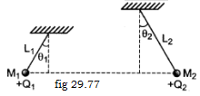63. Two small spheres of masses M1 , and M2 are suspended by weightless insulating threads of lengths L1, and L2. The spheres carry charges of Q1 and Q2 respectively. The spheres are suspended such that they are in level with one another and the threads are inclined to the vertical at angles of θ1 and θ2 as shown in fig 29.77. Which one of the following conditions is essential if θ1 = θ2? [CET (Karnataka) 2010]

(a) M1 ≠ M2 but Ql = Q2 (b) M1 = M2

(c) Ql = Q2 (d) L1 = L2



64. There is a uniform electric field of intensity E which is as shown adjoining figure 29.78. How many labelled points have the same electric potential as the fully shaded point? [CET (Karnataka) 2010]

(a) 2 (b) 3 (c) 8 (d) 11

65. Positive and negative point charges of equal magnitude are kept at (0,0,a/2) and (0,0,-a/2) respectively .The work done by the electric field when another positive point charge is moved from (- a,0,0) to (0, a, 0), is :

(a) positive (b) negative

(c) zero (d) depends on the path connecting the initial and final positions

66.The potential at a point P due to an electric dipole is 1.8 x 105 V. If P is at a distance of 50 cm apart from the centre O of the dipole and if CP makes an angle 600 with the positive side of the axial line of the dipole, what is the moment of the dipole?

(a) 10 C-m (b) 10-3 C-m (c) 10-4 C-m (d) 10-5 C-m

67. The maximum electric field that can be held in air without producing ionisation of air is 107 v/m. The maximum potential therefore, to which a conducting sphere of radius 0.10 m can be charged in air, is :

(a) 109 V (b) 108 V (c) 107  V (d) 106 V

68. A particle of mass 2g and charge lμc is held at a distance of lm from a fixed charge l mC. If the particle is released it will be repelled. The speed of the particle when it is at a distance of 10 m from the fixed charge, is : (a) 90 m/s (b) 100 m/s (c) 45 m/s (d) 55 m/s

69. Two infinitely long parallel conducting plates having surface charge densities +σ and -σ respectively, are separated by a small distance. The medium between the plates is vacuum. If ∈o is the dielectric permittivity of the vacuum, then the electric field in the region between the plates, is :

(a) 0 volt/m (b) σ / 2∈o volt/m (c) σ / ∈o volt/m (d) 2σ /∈o volt/m

70. Two concentric conducting thin spherical shells A and B having radii rA and rB (rA < rB) are charged to QA & - QB , with magnitude of QB > magnitude of QA. The electric field along a line passing thru the centre is

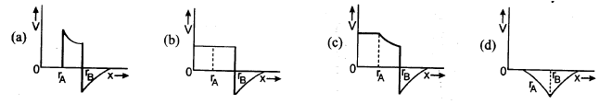

71. In the case of a parallel plate capacitor, when the distance between the two plates is reduced to one third and the area of the plate doubled, the capacitance

(*a*) remains the same (*b*) is doubled (*c*) increases to five times (*d*) increases to six times.

72. If *N* identical capacitors each of capacity *C* are connected in series, then its equivalent capacitance is

(*a*) *NC* (*b*) *N/C* (*c*) *C /N* (*d*) *NC*2.

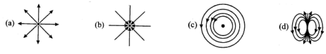73. which of the field patterns given in the figure is valid for electric field as well as for magnetic field [IIT 2011]

74. The electrostatic potential inside a charged spherical ball is given by : v = ar2 + b, where r is the distance from the centre; a, b are constants. Then, the charge density inside the ball is : [AIEEE2011]

(a) - 24πa∈or (b) - 6a∈or (c) - 24πa∈o (d) - 6a∈o

75. Two identical charged spheres suspended from a common point by two massless strings of length L are initially a distance d(d <<L) apart because of their mutual repulsion. The charge begins to leak from both the spheres at a constant rate. As a result the charges approach each other with a velocity *v*. Then, as a function of distance *x* between them is: [AIEEE2011]

(a) *v α x -1/2* (b) *v α x -1* (c) *v α x 1/2* (d) *v α x*

76. Electric charge is uniformly distributed along a long straight wire of radius 1 mm. The charge per cm length of the wire is Q coulomb. Another cylindrical surface of radius 50 cm and length 1m symmetrically encloses the wire. The total electric flux passing through the cylindrical surface, is

(a) *Q/∈o* (b) *100* *Q/∈o* (c) *10 Q/π∈o* (d) *100 Q/π∈o* (e) *Q/100∈o*

77. A dipole of electric dipole moment p is placed in a uniform electric field of strength E. If θ is the angle between positive directions of p and E,then the potential energy of the electric dipole is largest when θ is

(a) *π/4* (b) *π/2*  (c) *π*  (d) *zero*  (e) 2*π/3*

78. Two conducting spheres of radii 3cm and lcm are separated by a distance of l0cm in free space.If the spheres are charged to same potential of 10v each , then the force of repulsion between them is :

(a) 10-9/3 N (b) 2 x 10-9/9 N (c) 10-9/9 N (d) 4 x 10-9/3 N (e) 2 x 10-9/3 N

79. If q1 + q2 = q ,then the value of the ratio q1/q, for which the force between q1 and q2 is maximum is

(a) 0.25 (b) 0.75 (c) 1 (d) 0.5 (e) 1.5

80. The total electric flux emanating from a closed surface enclosing an α-particle (e-electronic charge) is :

(a) *2e/∈o* (b) *e/∈o* (c) *e∈o* (d) *e∈o/4* (e) *4e/∈o*

81. The work done in carrying a charge q once round a circle of radius a with a charge Q at its centre is :

(a) *qQ/4π∈o a*  (b) *qQ/4π∈o a2*  (c) *q/4π∈o a*  (d) *q/4π∈o a2* (e) *zero*

82. Two charges of magnitude l0 units and 20 units are separated by a certain distance. Now both the charges are brought ,to contact, and again separated-to initial position. What will be the ratio of initial and final force? (a) 9/8 (b) 4/3 (c) 3/2 (d) 8/9

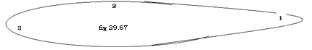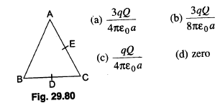83. Three charges, each + q are placed at the corners of an isosceles triangle of each side 2a( AC=BC =2a).Sides BC and AC have D and E as their midpoint. The work done in taking a charge Q from D to E is (fig 29.80) :

84. Consider a non-spherical conductor shown in the figure 29.67 which is given a certain amount of positive charge. The charge distributes itself on the surface such that the charge densities are σ1, σ2 and σ3 at the regions 1, 2 and 3 respectively. Then:

(a) σ1> σ2 > σ3  (b) σ2 > σ3 >σ1 (c) σ3 > σ1 >σ2 (d) σ2 > σ1 >σ3 (e) σ1 > σ3 >σ2

**Objective Capacitance**

85. Six equal capacitors each of capacitance C are connected as shown in the figure 30.9. Then the equivalent capacitance between A and B is :

(a) 6C (b) C (c) 2C (d) C/2

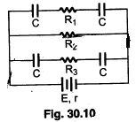86.In the given circuit diagram(30.10) E=5V , r = 1ohm,R2 =4 ohm; R1=R3=1ohm and C = 3μF. Then the numerical value of the charge on each plate of the capacitor is

(a) 24μC (b) 12μC (c) 6μC (d) 3μC

87.The unit of electric field V/m can also be written as

(a) N/C (b) C/N (c) A/m (d) F/m

88.A parallel plate condenser-with plate area A and separation d is filled with two dielectric materials as shown in the figure 30.12given below. The dielectric constants are K1 & K2 respectively. The capacitance will be :

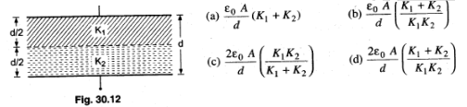

89. A number of capacitors each of capacitance l μF and each one of which get punctured if a potential difference just exceeding 500 volt is applied, are provided. Then an arrangement suitable for giving a capacitor of 2μF across which 3000 volt may be applied requires at least:

(a) 18 component capacitors (b) 36 component capacitors

(c) 72 component capacitors (d) 144 component capacitors

90. A capacitor of capacitance lμF withstands a maximum voltage of 6 kV, while another capacitor of capacitance 2 μF, the maximum voltage 4 kV. If they are connected in series, the combination can withstand a maximum of: (a) 6kV (b) 4kV (c) 10kV (d) 9kV

91. Seven capacitors each of capacitance 2μF are to be connected to obtain a capacitance of (10/11) μF. Which of the following combinations is possible?

(a) 5 in parallel, 2 in series (b) 4 in parallel, 3 in series

(c) 3 in parallel, 4 in series (d) 2 in parallel, 5 in series

92. Condenser A has a capacity of 15 μF when it is filled with a medium of dielectric constant 15. Another condenser B has a capacity of l μF with air between the plates. Both are charged separately by a battery of 100 V. After charging, both are connected in parallel without the battery and the dielectric material being removed. The common potential is now: (a) 400 V (b) 800 V (c) 1200 V (d) 1600 V

93. Two capacitors 2 μF and 4 μF are connected in parallel. A third capacitor of 6 μF capacity is connected in series. The combination is then connected across a 12 Y battery. The voltage across 2μF capacitor is :

(a) 2 volt (b) 6 volt (c) 8 volt (d) 1 volt

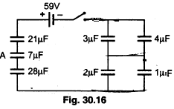

94. Seven capacitors, a switch S and a source of emf are connected as shown in the fig 30.16.Initially S is open and all capacitors are uncharged. After S is closed & a steady state is obtained , the potential difference (in volts) across the plates of the capacitor A is

(a) 12 (b) l5 (c) 17 (d) l9

95. Four identical capacitors are connected in series with a l0 V battery as shown IN FIG 30.17. The point N is earthed. The potentials of points A and B are (a) 10 V, 0V (b) 7.5 V, -2.5 V (c)5V,-5V (d) 7.5 V, 2.5 V

96. A parallel plate capacitor with air as medium between the plates has a capacitance of 10 μF. The area of the capacitor is divided into two equal halves and filled with two media having dielectric constants K1 =2 and K2 = 4. The capacitance of the system will now be: (a) 10μF (b) 20μF (c) 30μF (d) 40μF

97. If a hollow spherical conductor is filled with a liquid, its capacitance changes from 4 μF to 12 μF. The dielectric constant of the liquid is (*a*) 2 (*b*) 4 (*c*) 8 (*d*) 3.

98. You are given 32 capacitors each having capacity 4 μF. How do you connect all of them to prepare a composite capacity having a capacitance 8 μF?

(a) 2 condensers in series and 16 such groups in parallel

(b) 8 condensers in series and 4 such groups in parallel

(c) 4 condensers in series and 8 such groups in parallel

(d) All of them in series

99. A dielectric is placed in between the two parallel plates of a capacitor as shown in figure30.18, the dielectric constant of the dielectric being K. If the initial capacity is C, then the new capacity will be:

(a) KC (b) (K + l)C (c) C(K +1)/2 (d) (K-1)C

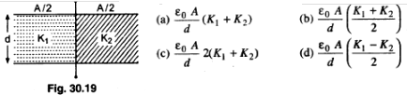100. A parallel plate condenser is filled with two dielectrics as shown in figure 30.19. Area of each plate is A metre2 and the separation is d metre. The dielectric constants are Kl and K2 respectively. Its capacitance in farad will be:

101.A parallel plate capacitor of area A, plate separation d and capacitance C is filled with three different dielectric materials having dielectric constants K1, K2 and K3 as shown IN FIG 30.20. If a single dielectric material is to be used to have the same capacitance C in this capacitor, then its dielectric constant K is, given by : (A = Area of plates) [IIT 2000]

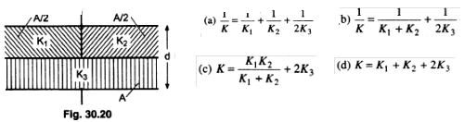

102. Two spherical conductors A and B of radii a and b(b> a) are placed concentrically in air as shown in fig. 30.22. B is given a charge +Q and A is earthed. The equivalent capacitance of the system is:

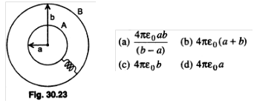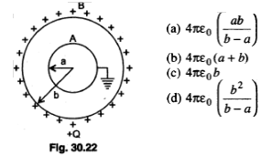

103. Two spherical conductors A and B of radii a and b(b> a) are placed concentrically in air. The two are connected by a copper wire as shown in figure 30.23. Then the equivalent capacitance of the system is :



104. The numerical value of the charge on either plate of the capacitor C shown in the figure 30.24 is:

(a) CE (b) CER1/(R2+r) (c) CER2/(R2+r) (d) CER1/(R1+r)

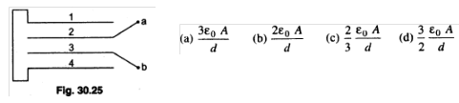105. Four metallic plates, each with a surface area of one side A, are placed at a distance d from each other. The plates are connected as shown in the adjoining figure 30.25. Then the capacitance of the system between a and b is:

106. Four metallic plates, each with a surface area of one side A, are placed at a distance d from each other in fig 30.26. The alternating plates are connected to points A and B as shown in the figure. Then the capacitance of the system is:

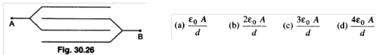

107. Four metallic plates each with a surface area of one side A(fig.30.27), are placed at a distance d from each other. The two outer plates are connected to one point A and the two other, inner plates to another point B as shown in the figure . Then, the capacitance of the system is:

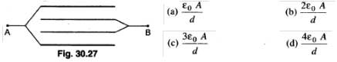



108. Three capacitors are connected to a DC source of 100 volts as shown in figure. If the charges accumulated on the plates of C1 ,C2 and C3 are qa, qb, qc, qd, qe , and qf respectively then fig 30.28:

(a) qb + qd + qf =100/9 C (b) qb + qd + qf =0 C

(c) qa + qc + qe =50 C (d) qb = qd = qf

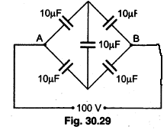

109. Five capacitors of l0 μF capacity are arranged as shown in fig 30.29.Find capacitance between the points A and B.

110. The dimensions of potential difference are

(*a*) MLT–2  (*b*) MLT2 (*c*) ML2 (*d*) ML2T–3A–1.

111. A parallel plate capacitor is connected to a battery. The plates are pulled apart with a uniform speed *v*.lf x is the separation between the plates, then the time rate of change of the electrostatic energy of the condenser is proportional to:

(a) *x2 (b) x (c) 1/x (d) 1/x2*

112.A parallel plate capacitor is charged and the charging battery is then disconnected. If the plates of the capacitor are moved, further apart by means of insulating handles, then which of the following is not correct?

(a) The capacitance decreases. (b) The charge on the capacitor increases.

(c) The voltage across the plates increases.

(d) The electrostatic energy stored in the capacitor increases.

113. A parallel plate capacitor of capacity 100 μF is charged by a battery of 50 volt. The battery remains connected and if the plates of the capacitor are separated so that the distance between them becomes double the original distance, the additional energy (in joule) given to the battery by the capacitor is:

(a) *62.5 x 10 -3/2 (b) 12.5 x 10 - 3 (c) 1.25 x 10 -3 (d) 0.125 x 10 - 3*

114.Minimum number of 8 μF and 250V capacitors used to make a combination of 16 μF and 1000 V are:

(a) 32 (b) 8 (c) 4 (d) 2

115. A capacitor of 10 μF is charged up to 250 volt is connected in parallel with another capacitor of 5 μF charged up to 100 volt. The common potential is:

(a) 500 V (b) 400 V (c) 300 V (d) 200V

116. The capacities of three capacitors are in the ratio l :2 :3. Their equivalent capacity when connected in parallel is 60/11 μF more than that when they are connected in series. The individual capacitors (in μF) are of capacities: (a) 4,6,7 (b) 1,2, 3 (c) 2,3, 4 (d) l, 3, 6

117. A capacitor of capacity 10 μF is charged to 40 volt and a second capacitor of capacity 16 μF is charged to 30 volt. If they are connected in parallel the amount of charge that flows from the smaller capacitor to the higher capacitor (in μC) is: (a) 320 (b) 60 (c) 200 (d) 250

118. A thin metal plate P is inserted half-way between the plates of a parallel plate capacitor of capacitance C in such a way that it is parallel to the two plates. The capacitance now becomes:

(a) C (b) C/2 (c) 4C (d) none of these

119. Two capacitors C1 and C2=2C1 are connected in a circuit with a switch between them as shown in fig 30.44.Initially the switch is open and C1 holds charge Q. The switch is closed. At steady state , the charge on each capacitor will be

(a) Q, 2Q (b) Q/3 , 2Q/3 (c) 3Q/2 , 3Q (d) 2Q/3 , 4Q/3

120. A parallel plate capacitor has an electric field of 105 V/m between the plates. If the charge on the capacitor plate is 1 μC, the force on each capacitor plate is:

(a) 0.5 N (b) 0.05 N (c) 0.005 N (d) none of these



121. In the circuit shown in the fig 30.45,C=6μF. The charge on the capacitor of capacity C is (a) zero (b) 90μC (c) 40μC (d) 60μC

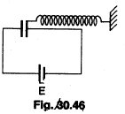

122. One plate of a capacitor is connected to a spring as shown in fig 30.46.Area of both plates is A. In steady state separation between the plates is 0.8d (spring was unstretched and the distance between the plates was d ,when the capacitor was uncharged).The force constant of the spring is approximately : (a) 4∈oAE2/d3 (b) 2∈o AE/d2 (c) 6∈oE2/Ad3 (d) ∈oAE3/2d3

123. Capacity of an isolated sphere is increased n times when it is enclosed by an earthed concentric sphere. The ratio of their radii is (a)n2/(n-1) (b)n/(n-1) (c)2n/(n+1) (d)(2n+1) /(n+1)

124. Three conducting spheres A,B & C are as shown in fig 30.47.The radii of the spheres are a,b and c respectively. A & B are connected by a conducting wire. The capacity of the system is :

(a) 4π∈o (a+b+c) (b) 4π∈o(bc)/(c-b)

(c) 4π∈o[1/a +1/b +1/c] (d) 4π∈oabc/(ab+bc+ca)

125. The metal plate on the left in the figure 30.48 carries a charge +q. The metal plate on the right has a charge of -2q.What charge will flow thru S when it is closed ,if the central plate is initially neutral?

(a) zero (b) -q (c) +q (d) +2q



126. Two identical capacitors I and 2 are connected in series to a battery as shown in the figure 30.49.Capacitor 2 contain a dielectric slab of dielectric constant K as shown.Q1 and Q2 are the charges stored in the capacitors. Now the dielectric slab is removed, and the corresponding charges become Q11 and Q22 then :

(a) Q11 / Q1 =(K+1)/K (b) Q22 / Q2 =(K+1)/2 (c) Q22 / Q2 =(K+1)/2K (d) Q11 / Q1 = K/2



127. An insulator plate is passed between the plates of a capacitor then current fig 30.50 :(a) always flows from A to B. (b) always flows from B to A.

(c) first flows from A to B and then from B to A.

(d) first flows from , B to A and then from A to B.

128. Between the plates of a parallel plate capacitor of capacity C , two parallel plates , of the same material and area same as the plate of the original capacitor, are placed. If the thickness of these plates is equal to 1/5th of the distance between the plates of the original capacitor, then the capacity of the new capacitor is:

(a) 5C/3 (b) 3C/5 (c) 3C/10 (d) 10C/3

129.A sheet of aluminium foil of negligible thickness is introduced between the plates of a capacitor. The capacitance of the capacitor

(a) increases (b) decreases (c) becomes infinite (d) remain unchanged

130.A spherical drop of capacitance 1μF is broken into eight drops of equal radius. The capacitance of each small drop is: (a) 1/2μF (b) 1/4μF (c) 1/8μF (d) 1/16μF



131.The effective capacitance between A & B in the fig. 30.51

(a) 21 (b) 23 (c) 3/14 (d) 14/3

132. A 40 μF capacitor is a defibrillator is charged to 3000 V. The energy stored in the capacitor is sent through the patient during a pulse of duration 2 ms. The power delivered to the patient is (a) 45 kW (b) 90 kW (c) 180 kW (d) 360 kW

133. A capacitor of capacitance 160 μF is charged to a potential difference of 200 volt and then connected across the discharged tube which conducts until the potential difference across it has fallen to 100 volt. The energy dissipated in the tube is:

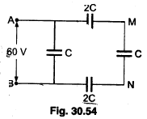(a) 6.4 J (b) 4.8 J (c) 4.2 J (d) 2.4 J

134. A capacitor charged to l0V is discharged by connecting the two plates at t = 0s.If the potential difference across the plates drops to I volt at t =5 ms, the potential difference at t = 10 ms is:

(a) 0.1 volt (b) 0.2 volt (c) 0.01 volt (d) 0.02 volt

135. In the circuit shown fig 30.54, a potential difference of 60 V is applied across AB. The potential difference between the points M & N is

(a) 10 V (b) 15 V (c) 20 V (d) 30V



136. Three conducting plates are given charges as shown in the figure30.55. If the cross-sectional area of each plate is same, the final charge distribution on plate C is:

(a) +5Q on the inner surface , +5Q on the outer surface

(b) +6Q on the inner surface, +4Q on the outer surface

(c) +7Q on the inner surface , +3Q on the outer surface

(d) +8Q on the inner surface, +2Q on the outer surface

137. Two identical sheets of a metallic foil are separated by ‘d’ and capacitance of the system is C and charged to a potential difference E. Keeping the charge constant, the separation is increased by *l*. Then the new capacitance and potential difference will be :



(a) ∈oAE/d (b) ∈oAE/(d+*l* )

138. A capacitor of capacitance C is connected to a cell of emf V and when charged it is disconnected. Now. the separation between the plates is doubled. The change in flux of electric field through a closed surface enclosing the capacitor is: (a) zero (b) CV/∈o (c) CV/2∈o (d) 2CV/∈o

139. Five identical capacitors when connected in series produce equivalent capacitance of 6 μF. Now. these capacitors are rearranged so as to produce maximum value of equivalent capacitance. The maximum value will be: (a) 30 μF (b) 36 μF (c) 150 μF (d) 6 μF

140. The expression for the equivalent capacitance of the system shown in fig 30.57 is:(A is the cross-sectional area of one of the plates)

(a) ∈oA/3d (b) 3∈oA/d (c) ∈oA/6d (d) none of these

141. The spheres shown in the figure 30.58 are connected by a conductor. The capacitance of the system is :

(a) 4π∈oC1(ab)/(b-a) (b) 4π∈oa

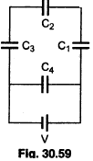 (c) 4π∈ob (d) 4π∈o(a2)/(b-a)

142. A fully charged capacitor has a capacitance C. It is discharged thru a small coil of resistance wire embedded in a thermally insulated block of specific heat capacity ‘s’ and mass ‘m’ .If the temperature of the block is raised by ∆T , the potential difference V across the capacitor is (a) (ms∆T/C) (b) √(2ms∆T/C) (c) √(2m∆TC/s) (d) (mC∆T/s)

143.A network of four capacitors of capacity equal to C1 = C, C2 = 2C, C3 = 3C and C4  = 4C are connected to a battery as shown in the figure 30.59. The ratio of the charges on C2 and C4 is: (a) 4/7 (b) 3/22 (c) 7/4 (d) 22/3.

144. Across each of two capacitors of capacitance I μF and 4 μF, a potential difference of l0 V is applied. Then positive plate of one is connected to the negative plate of the other, and negative plate of one is connected to the positive plate of the other. After contact:

(a) charge on each is zero (b) charge on each is same but non-zero

(c) charge on each is different but non-zero (d) none of the above

145. Four identical capacitors are connected as shown in diagram 30.60. When a battery of 6 V is connected between A and B, the charge stored is found to be 1.5 μC. The value of C1 is:

(a) 2.5 μF (b) l5 μF (c) 1.5 μF (d) l μF (e) 0.1 μF

146. A 10μF capacitor is charged to a potential difference of 1000 V. The terminals of the charged capacitor are disconnected from the power supply and connected to the terminals of an uncharged 6 μF capacitor. What is the final potential difference across each capacitor? (a) 167 V (b) 100 V (c) 625 v (d) 250 V (e) 750 V

147. A parallel plate air capacitor is charged to a potential difference of V volts. After disconnecting the charging battery, the distance between the plates of the capacitor is increased using an insulating handle. As a result. the potential difference between the plates:

(a) increases (b) decreases (c) does not change (d) becomes zero

148. Five capacitors each of capacitance value C are connected as shown in the figure30.62 The ratio of capacitance between P and R and the capacitance between P and Q is:

(a) 3 : 1 (b) 5:2 (c) 2 :3 (d)1 :1

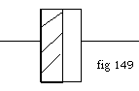

149. A parallel plate air capacitor has a capacitance C. When it is half filled with a dielectric of dielectric constant 5( fig 149), the percentage increase in the capacitance will be:

(a) 400% (b) 66.6% (c) 33.3% (d) 200%

150. A gang capacitor is formed by interlocking a number of plates as shown in the figure.30.63. The distance between the consecutive Plates is 0.885 cm and the overlapping area of the plates is 5 cm2. The capacity of the unit is:

(a) 1.06 pF (b) 4 pF (c) 6.36 pF (d) l2.72 pF



l51. The combined capacitance of the arrangement shown in the adjoining figure 30.64,is

(a) 30/11 (b) 8/11 (c) 4 (d)1



152. A network of six identical capacitors, each of value C, is made as shown in the figure30.65. The equivalent capacitance between the points A and B is

(a) C/4 (b) 3C/4 (c) 3C/2 (d) 3C (e) 4C/3

153. Two capacitors of capacitance C1 and C2 are connected in parallel. If a charge Q is given to the combination, the charge gets shared. The ratio of the charge on the capacitor Cl to the charge on the capacitor C2 is (a) C1C2 (b) C2/Cl  (c) C1 + C2  (d) C1/C2

154. A parallel plate capacitor of capacitance 1 pF has separation between the plates as d. When the distance of separation becomes 2d and wax of dielectric constant *x* is inserted in it, the capacitance becomes 2 pF. What is the value of x?(a) 2 (b) 4 (c) 6 (d) 8

155. lf a capacitor of capacitance 900 μF is charged to 100 V and its total energy is transferred to a capacitor of capacitance 100 μF, then its potential is:(a) 200 V (b) 30 V (c) 300 V (d) 400 V

156. A parallel plate capacitor of capacitance 100 pF is to be constructed by using paper sheets of 1 mm thickness as dielectric. If the dielectric constant of paper is 4, the number of circular metal foils of diameter 2 cm each required for the purpose is:(a) 40 (b) 20 (c) 30 (d) 10

157. Two capacitors of capacitance C are connected in series. If one of them is filled with dielectric substance K what is the effective capacitance?

(a) KC/(K+1) (b) C(K+1) (c) 2KC/(K+1) (d) None of these

158. A parallel plate condenser with a dielectric of dielectric constant K between the plates has a capacity C and is charged to a potential V volt. The dielectric slab is slowly removed from between the plates and then reinserted. The net work done by the system in this process is:

(a) zero (b) ½(K-1)CV2 (c) (K-1)CV2/K (d) (K-1)CV2

159. A battery is used to charge a parallel plate capacitor till the potential difference between the plates becomes equal to the electromotive force of the battery. The ratio of the energy stored in the capacitor and the work done by the battery will be: (a) ½ (b) 1 (c) 2 (d) ¼

160.The capacitance of a parallel plate capacitor with air as medium is 3 μF. With the introduction of a dielectric medium between the plates, the capacitance becomes 15 μF. The permittivity of the medium is:

(a) 5 (b) 15 (c) 0.44 x 10-l0 C2N-lm-2 (d) 8.854 x 10-l1 C2N-lm-2 (e) 5 C2N-lm-2

161. Two identical capacitors each of capacitance 5 μF are charged to potentials 2 kV and I kV respectively. The –ve ends are connected together. When the +ve ends are also connected together, the loss of energy of the system is: (a) 160 J (b) 0 J (c) 5 J (d) 1.25 J



162. A parallel plate capacitor with air as the dielectric has capacitance C(fig.30.67). A slab of dielectric constant K and having the same thickness as the separation between the plates is introduced so as to fill one-fourth of the capacitor as shown in the figure. The new capacitance will be:

(a) C(K+3)/4 (b) C(K+2)/4 (c) (K+1)C/4 (d) KC/4

163. The plates of a parallel plate capacitor with air as medium are separated by a distance of 8 mm. A medium of dielectric constant 2 and thickness 4 mm having the same area is introduced between the plates. For the capacitance to remain the same, the distance between the plates is:

(a) 8 mm (b) 6 mm (c) 4 mm (d) 12 mm (e) 10 mm

164. Two condensers, one of capacity C and other of capacity C/2 are connected to a V volt battery, as shown in the figure 30.68. The work done in charging fully both the condensers is:

(a) ¼CV2 (b) ¾CV2 (c) ½CV2  (d) 2CV2



165. What is the potential difference between A and B in the circuit shown(30.69)?

(a)2V (b)4V (c)3V (d) 12V

166. What is potential difference across 2 μF capacitor in the circuit shown(30.70)?

(a)12V (b)4V (c)6V (d) 18V

167.The time constant of the given circuit( fig 30.71) is :

(a)3RC/5 (b)6RC/5 (c)5RC/6 (d) none of the above



168. A circuit is connected as shown in the figure 30.72 with the switch S open. When the switch is closed, the total amount of charge that flows from Y to X is: (IIT 2007)

(a) 0 (b) 54 μC (c) 27 μC (d) 8l μC

169. A parallel plate capacitor with air between the plates has a capacitance of 9 pF. The separation between the plates is d. The space between the plates is now filled with two dielectrics. one of the dielectrics has dielectrics constant K1 =3 and thickness d/3 while the other one has dielectric constant K2 =6 and thickness 2d/3. Capacitance of the capacitor is now:

(a) 1.8 pF (b) 45 pF (c) 40.5 pF (d) 20.25 pF

170. A capacitor of capacitance value l μF is charged to 30 V and the battery is then disconnected. If it is connected across a 2μF capacitor, the energy lost by the system is:

(a)300μJ (b)450μJ (c)225μJ (d) 150μJ (e) 100μJ

171. A 20 μF capacitor is connected to 45 V battery through a circuit whose resistance is 2000 ohm. What is the final charge on the capacitor?

(a)9 x 10-4 C (b) 9.154 x 10-4 C (c) 9.8 x 10-4 C (d) none of these



172. Equivalent capacitance between X and Y points in the given figure 30.107 is :

(a) 2 μF (b)4μF (c) 3 μF (d) 1 μF



173. The energy stored in the capacitor as shown in Fig. (30.79a) is 4.5 x10-6 J. If the battery is replaced by another capacitor of 900 pF as shown in Fig. (b),then the total energy of the system is:

(a) 4.5 x 10-6 J (b) 2.25 x 10-6 J

(c) zero (d) 9x10-6 J

174. A cylindrical capacitor has charge Q and length L. If both the charge and length of the capacitors are doubled, by keeping other parameters fixed, the energy stored in the capacitor

(a) remains same (b) increases two times (c) decreases two times (d) increases four times

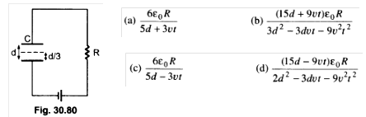

175. A parallel plate capacitor C with plates of unit area and separation d is filled with a liquid of dielectric constant K = 2(fig. 30.80). The level of liquid is d/3 initially. Suppose the liquid level decreases at a constant speed *v* the time constant as a function of time t is:

176. How does. the electric field (E ) between the plates of a charged cylindrical capacitor vary with the distance r from the axis of the cylinder

(a) E α 1/r2 (b) E α 1/r (c) E α r2 (d) E α r

177. The plates of a parallel plate capacitor are not exactly parallel. The surface charge density:

(a) is lower at the closer end (b) will not be uniform

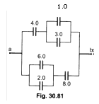(c) each plate will have the same potential at every point (d) both (b) and (c)

178. The equivalent capacitance between a and b for the combination of capacitors shown in the figure30.81 is:

(a) 6 μF (b) 4 μF (c) 2 μF (d) 3 μF



179. The charge deposited on 4 μF capacitor in the circuit(30.82) is:

(a) 6 x10-6 C (b) l2 x 10-6 C (c) 24x l0-6 C (d) 36 x 10-6 C

l80. Three capacitors each of capacitance C and of breakdown voltage V are joined in series. The capacitance and breakdown voltage of the combination will be:

(a) 3C,V/3 (b) C/3 ,3V (c) 3C,3V (d) C/3,V/3

181.C ,V , U and Q are capacitance, potential difference, energy stored and charge of a parallel plate capacitor respectively. The quantities that increase when a Dielectric slab is introduced between the plates without disconnecting the battery are:

(a) V and C (b) V and U (c) U and Q (d) V and Q (e) U but not Q

182. Energy stored per unit volume of a parallel plate capacitor having plate area A and plate separation d when charged to a potential of V volts is (air space in between the plates):

(a) ½C2V2 (b) Q2/4C (c) ½∈oV/d (d) ½∈o(V/d)2

183. Two parallel plate capacitors of capacitances C and 2C are connected in parallel and charged to a potential difference Vo. The battery is then disconnected and the region between the plates of the capacitor C completely filled with a material of dielectric constant 2. The potential difference across the capacitors now becomes

(a) Vo/4 (b) Vo/2 (c) 3Vo/4 (d) Vo

184. A series combination of n1 capacitors, each of value C1, is charged by a source of potential difference 4V. When another parallel combination of n2 capacitors, each of value C2,is charged by a source of potential difference V, it has the same (total) energy stored in it, as the first combination has. The value of C2, in terms of C1, is then (a) 2C1/ n1 n2 (b) 16C1 n2/ n1 (c) 2C1 n2/ n1 (d) 16C1/ n1 n2



185. Three capacitors are connected in the arms of a triangle ABC as shown in the figure(30.83).5V voltage is applied between A & B. The voltage between B & C is

(a) 2v (b) lV (c) 3V (d) 1.5V (e) 0.5V

186. A slab of material of dielectric constant K has the same area as the plates of a parallel plate capacitor but has a thickness (3/4)d, where d is the separation of the plates. The ratio of the capacitance C (in the presence of the dielectric) to the capacitance Co (in the absence of the dielectric) is :

(a) 3K/(K+4) (b) 3K/4 (c) 4K/(K+3) (d) 4K/3



187.All capacitors used in the diagram(30.85) are identical and each is of capacitance C. Then, the effective capacitance between the point A and B is:

(a) 1.5 C (b) 6 C (c)1c (d)3C

188. The capacity of a parallel plate capacitor with no dielectric substance but with a separation of 0.4 cm is 2μF. The separation is reduced to half and it is filled with a dielectric substance of value 2.8. The final capacity of the capacitor is : (a) 11.2 μF (b) 15.6 μF (c) 19.2 μF (d) 22.4 μF

189. Three capacitors of 2μF,3 μF and 6 μF are joined in series and the combination is charged by means of a 24 V battery. The potential difference between the plates of the 6 μF capacitor is :

(a)4V (b)6V (c)8V (d)10V

190. A capacitor is charged by using a battery which is then disconnected. A dielectric slab is introduced between the plates which results in :

(a) increase in the potential difference across the plates and reduction in stored energy but no change in the charge on the plates

(b) decrease in the potential difference across the plates and reduction in the stored energy but no change in the charge on the plates

(c) reduction of charge on the plates and increase of potential difference across the plates

(d) increase in stored energy but no change in potential difference across the plates

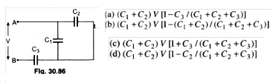

191. Three capacitors C1 , C2 and C3 are connected as shown in the figure(30.86) to a battery of V volt. If the capacitor C3 breaks down electrically the change in the total charge on the combination of the capacitors is :

192. A parallel plate condenser has a capacitance 50 μF in air and 100 μF in oil. The dielectric constant ε*r* of oil is (*a*) 0.45 (*b*) 0.55 (*c*) 2 (*d*) 0.5.

193. A parallel plate capacitor is connected to a 5 V battery and charged. The battery is then disconnected and a glass slab is introduced between the plates. Then, the quantities that decrease are :

(a) charge and potential difference (b) charge and capacitance

(c) capacitance and potential difference (d) energy stored and capacitance

(e) energy stored and potential difference

194. The potential difference between A and B(in fig 30.88), is

(a)13.2 V (b) -13.2 V (c) -6V (d) 6V



195. The equivalent capacitance between A and B as shown in figure(30.89), is(a) 25/26 μF (b) 1 μF (c) 3 μF (d) 3/4 μF



196. Total capacity of the system of capacitors shown in the

following figure30.5 between the points A and B is:

(a) 1 μF (b) 2μF (c) 3 μF (d) 4 μF



197. Five identical capacitors, each with capacitance C are connected as shown in the figure 30.8. find the equivalent capacitance

(a) C (b) 5C (c) C/5 (d) 3C

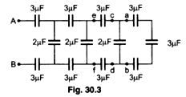

198.The resultant capacitance between A and B in the Fig. 30.3 is:

(a) 1 μF (b) 10μF (c) 50 μF (d) 1.5 μF



199. For the circuit shown in the figure 30.15, the charge on 4 μF

(a) 30μC (b) 40μC (c) 24μC (d) 54μC

200. The area of the plates of a parallel plate condenser is 100 cm2. The paper (K= 2.5)of thickness 0.005 cm is put in between the plates. If the paper can tolerate a field of 5 x 107 volt/m, the maximum potential up to which the condenser can be charged is:

(a) 2500 volt (b) 7500 volt (c) 500 volt (d) 10,000 volt

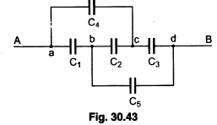

201. In the given figure 30.43 the capacitors C1,C3,C4 & C5 have a capacitance of 4μF each. If the capacitor C2 has a capacitance of 10μF, then the effective capacitance between A & B is (check question 197.)

(a) 2μF (b) 4μF (c) 6μF (d) 8μF

202. If a dielectric substance is introduced between the plates of a charged air-gap capacitor, the energy of the capacitor will:

(a) decrease (b) remain unchanged (c) increase (d) first decreases and then increases



203. AII the six capacitors shown in the circuit(30.53) are identical. Each can withstand maximum 200 volt between its terminals. The maximum voltage that can be applied safely between A and B is

(a) 800 v (b) 400 v (c) 1200 v (d) 200 v

204. An air capacitor C connected to a battery of emf V acquires a charge q and energy E. The capacitor C is disconnected from the battery and a dielectric slab is placed between the plates.Which of the following statements is correct?

(a) V and q decreases but C and E increases. (b) V remains unchanged, but q, E and C increases.

(c) q remains unchanged, C increases, V and E decreases. (d) q and C increases but V and E decreases

205. 27 small drops each having charge q and radius r coalesce to form big drop. How many times charge and capacitance will become? (a) 3,27 (b) 27, 3 (c) 27,27 (d) 3, 3

206. A capacitor having capacitance 1 μF with air is filled with two dielectrics as shown(30.66). How many

times capacitance will increase?

(a) 12 (b) 6 (c) 8/3 (d) 3



207. The total energy stored in the condenser system shown in the adjoining figure(30.74) will be

(a)2μJ (b)4μJ (c)8μJ (d) 16μJ



208. Plates of area A are arranged as shown(30.75). The distance between each two plates is d, the net capacitance is:

(a)∈oA/d (b)7∈oA/d (c)6∈oA/d (d) 5∈oA/d



209.Two parallel plate of area A are separated by two different dielectrics as shown in the figure(30.76). The net capacitance is: (a)4∈oA/3d (b)3∈oA/4d (c)2∈oA/d (d) ∈oA/d

210. Four capacitors of equal capacitance have an equivalent capacitance C1 when connected in series and an equivalent capacitance C2 when connected in parallel. The ratio C1/C2 is;(a) 1/4 (b) 1/16 (c) 1/8 (d) 1/12



211. The equivalent capacitance between A and B(30.84 FIG) is (in μF):

(a) 25 (b) 84/25 (c) 9 (d) 25/84 (e) 1

**Answers Objective (Electrostat – Ch -1 & Ch-2)**

|  |  |  |  |  |  |
| --- | --- | --- | --- | --- | --- |
| 1. A | 1. A | 1. E | 1. C | 1. B | 1. B |
| 1. C | 1. A | 1. B | 1. C | 1. A | 1. C |
| 1. D | 1. B | 1. B | 1. D | 1. C | 1. B |
| 1. C | 1. C | 1. B | 1. A | 1. D | 1. D |
| 1. B | 1. C | 1. A | 1. A | 1. C | 1. D |
| 1. A | 1. B | 1. D | 1. D | 1. A | 1. D |
| 1. A | 1. A | 1. A | 1. B | 1. A | 1. B |
| 1. B | 1. E | 1. A | 1. D | 1. C | 1. A |
| 1. C | 1. A | 1. C | 1. C | 1. A | 1. C |
| 1. D | 1. C | 1. D | 1. D | 1. D | 1. B |
| 1. B | 1. A | 1. B | 1. B | 1. C | 1. D |
| 1. D | 1. A | 1. C | 1. C | 1. D | 1. C |
| 1. C | 1. D | 1. A | 1. B | 1. C | 1. A |
| 1. D | 1. A | 1. E | 1. D | 1. D | 1. E |
| 1. C | 1. C | 1. A | 1. C | 1. C | 1. D |
| 1. A | 1. B | 1. B | 1. A | 1. B | 1. C |
| 1. D | 1. C | 1. C | 1. B | 1. B | 1. D |
| 1. C | 1. C | 1. D | 1. C | 1. B | 1. D |
| 1. D | 1. D | 1. D | 1. B | 1. A | 1. A |
| 1. D | 1. B | 1. B | 1. A | 1. B | 1. B |
| 1. C | 1. A | 1. B | 1. B | 1. C | 1. C |
| 1. D | 1. A | 1. D | 1. A | 1. D | 1. B |
| 1. D | 1. A | 1. D | 1. C | 1. C | 1. A |
| 1. C | 1. D | 1. C | 1. B | 1. B | 1. C |
| 1. E | 1. C | 1. A | 1. C | 1. B | 1. B |
| 1. C | 1. E | 1. D | 1. B | 1. C | 1. D |
| 1. A | 1. A | 1. A | 1. C | 1. D | 1. A |
| 1. E | 1. B | 1. A | 1. C | 1. B | 1. C |
| 1. C | 1. A | 1. A | 1. B | 1. B | 1. B |
| 1. A | 1. B | 1. D | 1. A | 1. C | 1. B |
| 1. C | 1. D | 1. C | 1. D | 1. A | 1. C |
| 1. A | 1. A | 1. A | 1. B | 1. A | 1. C |
| 1. E | 1. C | 1. C | 1. B | 1. A | 1. A |
| 1. C | 1. A | 1. B | 1. A | 1. B | 1. C |
| 1. B | 1. B | 1. C | 1. A | 1. A | 1. B |
| 1. E |  |  |  |  |  |

**Explanations Objective -Electrostat**

